**SUPPLEMENTARY INFORMATION**

**The Atlantic Forest trees: a flora on the verge of extinction**

(Author list)

(affiliations)

**This PDF file includes:**

1. Materials and Methods ............................................................................................... 2

2. Supplementary Tables and Figures .......................................................................... 20

1. **Materials and Methods**

**Study area.** Weassessed the conservation status for species occurring in the Atlantic Forest, which once covered about 1.63 million km2 of Eastern South America (4‒34oS latitude, 35‒57oW longitude), including parts in Brazil (92% of the total area), Paraguay (6%) and Argentina (2%). Home to over 148 million people (ca. 35% of South America human population), the Atlantic Forest in one of the hottest biodiversity hotspots in the world, combining high levels of habitat, carbon and biodiversity losses (less than 20% the original Atlantic Forest remains) and plant endemism levels between 40-50% (Ribeiro et al. 2009; Lima et al. 2020b, 2020a; Rosa et al. 2021). So, although we conducted species assessments regionally, the high endemism ratio of the Atlantic Forest assures that about half of the conservation status reported here are global.

**Group of organisms**.Weperformedassessments only for the native Atlantic Forest arborescent flora, defined here as species with free-standing stems normally exceeding 5 cm of diameter at breast height (d.b.h. at 1.3 m) or 4 m in total height. This definition was adapted from other definitions (Grandtner & Chevrette 2013; Beech et al. 2017) and it includes arborescent woody species (i.e. large shrubs, treelets and trees), palms, cactuses and ferns, which are often included in Atlantic Forest quantitative surveys. It also includes hemi-epiphyte trees (e.g. *Ficus*) and some trees with sporadic lianescent growth (e.g. *Dalbergia* and *Machaerium* species). Hereafter, we will refer to the life forms listed above simply as trees. We did not perform assessments for introduced and naturalized species or for woody bamboos occurring in the Atlantic Forest. Moreover, although we have compiled occurrence and abundance data (see details below) at the species and infra-specific levels (varieties, subspecies, etc), we performed assessments only at species level, which included a total of 4953 tree species (Appendix WW).

**Taxonomic level**. During data search, we assigned all identifications marked as cf. (*confer*) to the species suggested for confirmation, while we excluded identifications marked as aff. (*affinis*). We excluded species abundance data (more details below) from 250 small shrub species that had some data available but that rarely exceed 5 cm of dbh, mainly within Asteraceae, Erythroxylaceae, Loganiaceae, Melastomataceae, Piperaceae, Rubiaceae and Solanaceae. Species nomenclature followed the Brazilian Flora 2020 (BF-2020 ‒ Ranzato Filardi et al., 2018), which was used to check for synonyms and orthographical variants (Appendix YY). The nomenclature of species not included in the BF-2020 was verified using Tropicos (www.tropicos.org). We also used the BF-2020 to retrieve species common names (Appendix ZZ).

**Species endemism level**. As explained below, the assessments performed here are relative to Atlantic Forest sub-populations, although we used species occurrence records both inside and outside the Atlantic Forest to evaluate their ranges. Therefore, to tell apart regional from global assessments, we separated species into endemics and non-endemics to the Atlantic Forest. Here, we considered as an endemic to the Atlantic Forest those species classified as pure and near endemics by (Lima et al. 2020b), which corresponds to species with at least 85% of their valid herbarium occurrences within the Atlantic Forest limits. We also considered as endemic those species considered as an Atlantic Forest endemic in the BF-2020 (Ranzato Filardi et al. 2018), which also had more than half of their valid occurrences within the Atlantic Forest. Following (Lima et al. 2020b), we classified species with less than 15% and between 15 and 85% of their valid occurrences within the Atlantic Forest as occasional and widespread species, respectively.

**Species auto-ecology.** We compiled from the literature species growth form and potential adult height (Hmax), which were used to divide them into four groups: (i) large shrubs and treelets (<5 m), small trees (5–15 m), large trees (>15 m) and trees (size unknown). These groups were adapted from the standards proposed by the IUCN (www.iucnredlist.org/resources/classification-schemes) and they roughly correspond to species reaching their adult phases in the understory, midstory and upperstory of the forest. For simplicity, we included the IUCN classes ‘succulent trees’ and ‘ferns’ in the four classes listed above (Appendix CC)). In addition, we compiled from species ecological groups (i.e. pioneer, early-secondary, late-secondary and climax), wood density (WD - g cm-3) and seed mass (SM - g). Information on Hmax, WD and SM were obtained from hundreds of studies listed in (Lima et al. 2020a), but mainly from TreeAtlan version 2.0 (Oliveira-Filho 2010), the Global Wood Density Database version 1.0 (Chave et al. 2009) and other main sources (Almeida-Neto et al. 2008; Bello et al. 2017; Kew 2018). For WD and SM, we used genus-level averages if the information was not available at the species level (ter Steege et al. 2006; Chave et al. 2006).

We completed missing information on ecological groups for typical pioneer Neotropical genera (e.g. *Baccharis*, *Cecropia*, *Celtis*, *Piptocarpha*, *Trema*, *Urera* and *Vernonanthura*). Because ecological groups were not available for the majority of the species, we also used the information on WD and SM to classify species into ecological groups, assuming that these two functional traits are related to species growth and mortality rates (Thomas 1996a; King et al. 2006; Poorter et al. 2008). More specifically, we classified species as follows: pioneers= WD< 0.4 g cm-3 and SM< 0.1 g; early-secondary= 0.4<WD< 0.55 g cm-3 and 0.1<SM< 0.25 g; late-secondary= 0.7<WD< 0.85 g cm-3 and 0.75<SM< 1 g; and climax= WD> 0.85 g cm-3 and SM> 1 g (palms, ferns, cactuses and woody bamboos were excluded from this classification). Threshold values roughly corresponded to quantiles of WD and SM distribution for the Atlantic Forest tree species. Despite this classification effort, 57% of the species remained without information on their ecological groups.

**Species habitat and distribution.** We obtained species habitat information from the BF-2020 project (Ranzato Filardi et al. 2018) and we converted them into the IUCN classes (version 3.1. ‒ [www.iucnredlist.org/resources/habitat-classification-scheme](http://www.iucnredlist.org/resources/habitat-classification-scheme)), including some generalizations of habitat classes: (i) ‘Carrasco’, ‘Restinga’ and ‘Campinaranas’ as ‘Dry Shrublands’, (ii) ‘Igapó’ and ‘Várzea’ forests as ‘Swamp Forest’ and (iii) ‘Campos Rupestres’ and ‘Campos de Altitude’ as ‘High Altitude Grassland’ (Appendix OO). These generalizations and conversions were necessary to convert habitat information from the BF-2020 project into the IUN classes and they were similar to the one used from previous studies (Jung et al. 2020), although these authors also classify parts of the class iii described above as ‘Dry Shrubland’.

We also listed the countries of occurrence of each species, which was obtained from the locality information of the valid species occurrence data used here (see ‘Species occurrence data’ below) and completed for Brazil using information from the BF-2020 (Ranzato Filardi et al. 2018). For Argentina, Brazil, Chile and Mexico the same two sources were used to provide extra details on the state, province or region of species occurrences within these countries, whenever available (Appendix JJ).

**Species generation length**. Measurements of generation length for tropical trees are anecdotal, mainly because monitoring the mortality and reproduction for such long-lived organisms is challenging. We found studies reporting estimates of 70 years for *Eucalyptus* species (Fensham et al. 2020), 82 years for *Grias peruviana* (Fung & Waples 2017) and 100 years for *Euterpe* *globosa* (Valen 1975). Other authors assumed an overall generation time of 50 years for all tropical tree species in Panama and in the Amazon (Ricklefs 2012; ter Steege et al. 2015). For assessments of conservation status, the IUCN provides an approximative method to estimate generation length (IUCN Standards and Petitions Committee 2019): age of first reproduction + *z* × length of reproductive period, where *z* is a species-specific constant between 0 and 1. This method produces biases that are comparable to other methods (Fung & Waples 2017), particularly for species with larger generation lengths (>15 years), such as trees. We explored the parameter space of this equation using reasonable values for tropical tree species: 5‒50 years for the age of first reproduction; 15-100 years for the length of reproductive period and z values between 0.25‒0.45. As a result, the equation provided estimates of generation lengths from 9-13 years to 75-100 years (results not shown), which comprises the values found in the literature.

Obtaining species-specific generation lengths for entire Atlantic Forest tree flora would be unfeasible, so we used an approach based on species functional types (Kohler et al. 2000; Picard et al. 2012). So, to apply the IUCN criteria and conditions in practice (see ‘Assessment of species conservation status’ and Table SV), we used information on species growth forms and ecological groups to set generation lengths for 12 groups of species, plus the average values for species with missing information (Table ST). We assumed generation lengths ranging from 10 (i.e. pioneer shrubs) to 80 years (i.e. large, climax trees). Roughly, these extremes correspond to ages of first reproduction and lengths of reproductive period of 5 and 15-25 years for pioneer shrubs, and 40‒50 and 70-100 years for large, climax trees. The values assumed here are rather conservative regarding the estimates of turnover time (i.e. 1/annual mortality rate) between 13-500 years for different genera in the Amazon (median 78 years – (Baker et al. 2014)).

**Species occurrence data.** Weretrieved over 3 million herbarium records for the Atlantic Forest tree flora, both inside and outside this biodiversity hotspot. We submitted all records to a detailed cleaning and validation process, described in detail elsewhere (Lima et al. 2020b). In general lines, this procedure included the removal of (i) duplicated specimens across herbaria (23.7% of all records retrieved); (ii) invalid geographical coordinates (31.2% of records); (iii) duplicated geographical coordinates within species (18.6% of records); and (iv) spatial outliers within species (0.1% of records). To simplify the computation of the geographical range parameters of species (see details below), we also (v) removed non-neotropical records for species with extra neotropical occurrences (0.02% of records). Finally, for the ca. 810 thousand occurrences passing the five steps described above (Appendix XX), we (vi) classified them according to the level of confidence on species identification, as follows: high (i.e. type specimens or identification performed by a specialist of the corresponding botanical family – 37.7% of all valid records), medium (i.e. identification performed by plant taxonomists or occurrences of 51 species relatively easy to identify – 10.4%), low (identification not performed by plant taxonomists – 33.4%) and unknown (i.e. unknown, anonymous or missing species determinator name – 18.6%). As described below (section ‘Data quality’), these classes were treated differently in the assessments related to the IUCN criterion B.

Aiming to increase the number of species occurrences to perform the conservation assessments, we also included species occurrences from forest inventory data (see details in section ‘Species abundance data’ below). The inclusion of this additional data followed a similar validation process applied to herbarium data, which included the above-mentioned steps ii, iii, iv and v. As described below, inventory data had a high precision in their geographical coordinates. Although many inventories have consulted plant taxonomists to identify species, this information is not reported in all inventories, so we assigned a low level of confidence in species identification to all inventory occurrences. We include two extra filters to the occurrences from inventory data. First, we excluded all occurrences associated to accession numbers already in the herbarium data (about 25% of forest inventories also contained voucher information). Second, we included inventory occurrences only if they were at least 2 Km away from herbarium occurrences available for the same species. We added this step to avoid the inclusion of occurrences from the same study present both in herbarium and inventory data, but with different coordinate precision in the two sources of information. The 2 Km threshold represents the most common coordinate precision in the herbarium data set (see ‘Data quality’ below). About 90 thousand species occurrences from forest inventories were finally added to the species occurrence data set (Appendix XX).

**Species abundance data.** We obtained forest tree density (number of trees ha-1) and species abundances (number of individuals per site) from forest inventories stored in the Neotropical Tree Communities (TreeCo) database (version 4.1 − Lima et al. 2015). We obtained data on forest tree density from 1185 inventories including stems with dbh ≥ 5 cm, the criteria most commonly used in the Atlantic Forest (Lima et al. 2015). We extracted data on species abundances mainly from inventories using dbh ≥ 5 cm as the cut-off criteria (72% of the cases). But we added data from inventories using different cut-off criteria (e.g. dbh ≥ 2.5-3.2 or ≥10 cm) for areas with small sampling coverage (e.g. Argentina, Paraguay and NE Brazil), areas without any inventories in a 25 km radius or if inventories had large sampling efforts (≥ 1 ha), resulting in an overall total of 1133 surveys with species abundance data (total sampling effort: 1154 ha and 1.37 million trees; average effort: 1.1 ha, time interval: 1985‒2019). In respect to the remaining Atlantic Forest area (~225 km2 - (Argentina & WWF 2017)), these surveys represented a sampling coverage of ~ 0.005%. For both tree density and abundance data we did not consider inventories conducted in non-forest formations, forest edges, or in managed, planted or early secondary forests. We only used surveys having their geographical coordinates validated at the county level or below (e.g. farms, forest fragments). Thus, we had at least one abundance record for 62.7% of the total of 4953 tree species.

**Populational estimates.** To estimate the total number of individuals for each species, we first used universal kriging to generate predictions of forest tree density in a hexagonal grid (0.5o of resolution). Next, we obtained for each grid cell the proportion of forest cover across time, extracted from the ESA Land Cover series for the period between 1992 and 2018 (ESA 2017) and from historical reconstructions of land use for the period between 1940 and 1990 (Holz & Placci 2003; Huang et al. 2007; Leite et al. 2012; Dias et al. 2016). These reconstructions are approximate, but they allow to infer long-term deforestation patterns in the study area. We set 1850 as the year when the Atlantic Forest had ca. 100% of its original cover (Victor et al. 2005). Thirdly, we multiplied the mean prediction of tree density (trees dbh ≥5 cm ha-1) from the kriging model by the forest cover to obtain the predicted number of trees for each grid cell at each year. We did the same using the low and high values of the model 95% confidence interval, which was used as a measure of uncertainty in the number of trees estimated. We then used inverse distance weighting to model species relative abundance across the same Atlantic Forest grid. We multiplied the estimated relative abundances of each species by the predicted number of trees to obtain their estimated number of individuals (ter Steege et al. 2015). Finally, we corrected these estimates using the proportion of Atlantic Forest cover for each time interval. Therefore, our estimates on the number of individuals take into account the spatial variation in forest tree density, species densities and deforestation across the study area.

**Proportion of mature individuals**. As defined by the IUCN, population sizes are measured as number of mature individuals (IUCN Standards and Petitions Committee 2019), which implies knowing *p*, the proportion of mature individuals in the total population. As for generation lengths, information of *p* for tropical trees is scarce in the literature. We found values of 0.16-0.8 [median= 0.49] for Panama (Wright et al. 2005), 0.24-0.73 [median= 0.48] for Dominica (Thomas et al. 2015) and 0.03-0.74 [median= 0.3] for Malaysia (Thomas 1996b) for dbh cut-offs of 1 cm, and 0.1-0.93 [median= 0.58] for a dbh cut-off of 10 cm (Ouédraogo et al. 2018). We found no community-wide studies reporting *p* for a dbh cut-off of 5 cm. After some bibliographical search for Atlantic Forest species, we found a *p* estimate of 0.42 only for *Euterpe edulis* (Matos et al. 1999). Information on stem diameter at onset of maturity (*D*crit, *sensu* (Thomas 1996b)) are easier to find for Atlantic Forest species and some of the examples found were <5 cm for *Ilex paraguariensis* (Pires 2012), ~10 cm for *Euterpe edulis, Tapirira guianensis and Cecropia glaziovii* (Matos et al. 1999; Mendonça 2004; Negrão-Baldoni 2010) and 20 cm for *Parkia pendula* and *Araucaria angustifolia* (Bittencourt & Sebbenn 2007; Piechowski & Gottsberger 2008; Paludo et al. 2009).

Once again, finding species-specific value of *p* or *D*crit for all Atlantic Forest species would be unfeasible. The IUCN recommends that “*p* should be selected based on knowledge of the taxon (...) rather than being set to a default value (such as 0.5)” (IUCN Standards and Petitions Committee, 2019, p.26). From the studies assessing *p* for tropical trees, we know that *p* is higher for smaller and for early-successional, faster-growing species (Thomas et al. 2015). Thus, we once again used an approach based on functional types (Kohler et al. 2000; Picard et al. 2012) to define values of *D*crit between 5 and 20 cm for different types (Table SU). These values of *D*crit were based on previous studies (Thomas 1996b; Wright et al. 2005; Thomas et al. 2015; Ouédraogo et al. 2018), but none of them was conducted using 5 cm dbh. Thus, we set a more conservative range then what is reported in these studies (*D*crit: 1-46.7 cm) to avoid very low values of *p* for some functional types. We also assumed that all shrubs to have a *D*crit= 5 (*i*.*e*., all individuals are mature). Based on these *D*crit values, we used ground-data of tree measurements in 41 sites of Atlantic Forest (total 108,226 tree measurements, dbh≥ 5cm) to estimate the average proportion [and the 95% confidence intervals] of individuals above *D*crit (Table SU). These averages were thus used here as proxies of *p* for the species included in the assessments.

**Assessment of species conservation status.** We performed a multiple-criteria assessment of species conservation status following the IUCN Red List Categories and Criteria version 3.1, following the version 14 of the IUCN guidelines to their application (IUCN Standards and Petitions Committee 2019). Here we define these assessments as preliminary, because they were conducted automatically and thus not submitted to the species-by-species revision and justification require to enter the IUCN system (Stévart et al. 2019). For instance, we have not performed in-depth assessments based on species uses or ongoing conservation actions that could be used to up-list or down-list assessments. However, we have made a considerable effort to adhere to the IUCN criteria and recommendations as much as possible, and we provide as much information as possible so that these assessments can be more easily entered in the IUCN system.

IUCN Criteria

As explained in details below, assessments were based on population size reduction (criteria A2), species geographic range (criteria B1 and B2), small and declining populations (criteria C1 and C2) and very small populations (criterion D1). We only considered natural occurrences and populations, that is, trees in botanical gardens or cities were not taken into account. We set 2018 as the assessment year for all species (last year available of forest cover maps), although we used more recent occurrence data. In the case of species meeting different categories of conservation status using different criteria, we assumed the highest category as recommended by the IUCN (2019), but we document the categories obtained from the application of each criterion (Appendix WW).

To apply the criterion A, we relied on ‘b: an index of abundance appropriate to the taxon’ for species with both abundance and occurrence data available. For species with only occurrence data available, we used the base ‘c’ (decline in the area of occupancy - AOO). Similarly, we used conditions ‘a’ (number of locations) and ‘b’ (continuing decline in habitat area) for criterion B. Finally, for sub-criteria C2 assessments refers to small populations highly concentrated in single populations (see Table SV for all the sub-criteria, bases and conditions used here). We did not attempt to quantify criterion D2, since species-specific information on future threats is currently unavailable. In addition, we also did not quantify extreme fluctuations in population sizes (i.e. B1c/B2c or C2b), under the assumption that the establishment, growth and reproduction of tropical trees take too long (i.e. decades to centuries) to allow ‘wide, rapid and frequent’ variations in population sizes (IUCN Standards and Petitions Committee 2019).

Red List categories

We considered the following Red List categories (**Fig. 1**): Least Concern (LC), Near Threatened (NT), Vulnerable (VU), Endangered (EN), Critically Endangered (CR) and Data Deficient (DD). We classified as LC species that were not qualified as NT, VU, EN, or CR after applying criteria A, B, C and D. We classified species as NT if they were initially classified as LC under the four criteria, but close to qualifying for VU, following the IUCN suggestions of particular cases (IUCN Standards and Petitions Committee, 2019, p.76-77). For threatened categories VU, EN and CR, we used the standard IUCN thresholds and conditions (IUCN Standards and Petitions Committee, 2019, p.16). Considering that there are significant and ongoing threats to Atlantic Forest species (see details below) and that the Atlantic Forest has one of the most well sampled floras in the tropics, we tagged as ‘CR (Possibly Extinct)’ all species classified as CR using criteria A, B, C and/or D that are only known from its type specimen locality and had not been recollected in the past 50 years (IUCN Standards and Petitions Committee, 2019, p.72). On the other hand, because the assessments were not performed species-by-species, we did not attempt to assign the categories Extinct, Extinct in the Wild, or Regionally Extinct.

We classified species as DD if the available data was insufficient to place the species into a category of threat. The IUCN recommends that one “should use whatever information is available (...) and place taxa into the Data Deficient category only when there is really no alternative” (IUCN Standards and Petitions Committee 2019). Here, we considered as DD only when the taxon was listed for the Atlantic Forest but had no valid occurrence record at all (cannot assess criterion B) *AND* no population data (cannot assess criteria A, C or D).

**Regional assessments**. As recommended by (IUCN 2012), regional assessments have an additional step after the application of the IUCN categories and criteria. This additional step is necessary because conspecific populations outside the target region can lessen the extinction risk of the populations within the region, through a rescue effect (IUCN 2012). Here, we applied the guidelines of regional assessments as follows. For all Atlantic Forest pure and near-endemic species the assessments obtained from the application of the IUCN categories and criteria were not changed. Species classified as ‘occasional’ in the Atlantic Forest (Lima et al. 2020b) were taken here as vagrant taxa (*sensu* (IUCN 2012)). Occasional species had their category changed to ‘Not Applicable’ (NA), except for species categorized as threatened under criterion B, which used all species occurrences available, both inside and outside the Atlantic Forest (**Fig. 1**).

We down-listed assessments only for 130 ‘widespread’ species which are recognized as ‘specialists’ of other regions neighboring the Atlantic Forest: the Caatinga, Cerrado, Pantanal and Pampa domains. A species was considered as a ‘specialist’ of another domain if it was cited as occurring only in one or more of these four domains and not in the Atlantic Forest in the Brazilian Flora 2020 (BF-2020 ‒ (Ranzato Filardi et al. 2018)). The same was done for species cited in the BF-2020 as occurring only in the typical vegetation types of those domains (e.g. ‘Campo Limpo’ or ‘Carrasco’) and not in the different Atlantic Forest vegetation types. Thus, we assumed that the populations of those species to be larger in these neighboring domains, with a potential rescue effect in the Atlantic Forest populations. Species with disjunct populations between the Atlantic Forest and the Amazon, Andes or the Caribbean were considered to be isolated and thus the assessments for the Atlantic Forest populations were not changed. It should be noted that the general conditions in the domains neighboring the Atlantic Forest are deteriorating and that current conservation measures probably will not improve the habitat quality and/or quantity soon (Beuchle et al. 2015). These are two of the examples when the rescue effect from outside populations may not be significant (IUCN 2012). Therefore, the down-listing performed here is rather conservative, particularly if we take into relatively low dispersal ability of tree individuals.

**Population size reduction (IUCN criterion A).** Here we assumed that species population sizes are linearly related to habitat availability (i.e. forest cover), and that their reduction is mainly caused by reductions in forest cover though time, i.e. deforestation (ter Steege et al. 2015). These are reasonable assumptions for long lived, forest-dependent and sessile organisms such as trees (IUCN Standards and Petitions Committee 2019). For species with commercial value (e.g. timber), we also took into account inferred reductions of population sizes from exploitation (see details below). But for other species, these assumptions may be oversimplistic because they do not take into account the impacts of forest fragmentation and degradation on population dynamics (ter Steege et al. 2015). Some early-successional species may be less impacted then late-successional species in fragmented landscapes. In addition, we assumed that climatic changes or biological invasions have not altered species densities over the past three decades. Therefore, although the main driver of change in the Atlantic Forest undoubtedly is forest loss and that we use field abundance data to derive population sizes, their decline is an estimation regarding its nature of evidence (*sensu* (IUCN Standards and Petitions Committee 2019)).

For the assessments using the IUCN criterion A, we consider that the causes of population reductions in the Atlantic Forest, i.e. deforestation, are well identified and understood. But we consider that they are not clearly reversible or have not ceased, which implies the use of the sub-criterion A2. We justify this decision based on the following facts: (i) many deforested parts of the Atlantic Forest (i.e. cities, highly-profitable agricultural lands) will never become forest again, despite the current efforts and commitments to the restoration of the Atlantic Forest (REFS); (ii) although deforestation rates have greatly decreased in the Atlantic Forest since 2000, over 50,000 ha of old-growth forests are still lost each year and deforestation rates are even higher in some Brazilian states and in Paraguay (Argentina & WWF 2017; SOS Mata Atlântica & Instituto Nacional de Pesquisas Espaciais (INPE) 2018; Rosa et al. 2021); and (iii) secondary forests or small, degraded forest fragments may be not be a suitable habitat for many late-successional species, meaning population reductions may not be reversible or will take a long time to occur. Here, we did not attempt to exclude the forest cover that could be classified as unsuitable habitats (i.e. very degraded or small forest patches), which would require spatialized information on habitat quality and species-specific information on habitat association (not available for the majority of the species). Therefore, our estimates of population reduction are conservative for the majority of the species. Despite we decided to use sub-criterion A2, we provide the results of the assessments under sub-criterion A1 for comparison (Appendix XX).

Species with abundance data (sub-criterion A2b)

The Atlantic Forest deforestation can be described by a period of low deforestation rates before 1940-1950, followed by an intense deforestation period until 1990-2000 (depending on the region) and a more or less stable period from 2000 until present days (Argentina & WWF 2017; SOS Mata Atlântica & Instituto Nacional de Pesquisas Espaciais (INPE) 2018; Rosa et al. 2021). This means that most Atlantic Forest populations were severely depleted in the past and are now more or less stable. Therefore, to interpolate population sizes for one, two and three generations in the past (IUCN Standards and Petitions Committee 2019), we compared the fit of five statistical models (i.e. linear, quadratic, exponential, logistic and generalized logistic) to population decline patterns before and after 1995 (i.e. first year with satellite-based forest cover map). Models were fitted separately for each species and the selection among the best candidate model for each period (i.e. before and after 1995) was based on the corrected Akaike Information Criterion, or AICc (Burnham & Anderson 2004). The IUCN does not suggest any maximum time limit for calculating past populational reductions (IUCN Standards and Petitions Committee 2019). However, because we set 1850 as the year when the Atlantic Forest had close to 100% of its original forest cover, we used 1850 as the upper limit for all assessments, even for species in which the three generations represented a date before 1850. Finally, to delimit periods of population decline or stability, we also fitted piece-wise regression to the population size data of each species (Appendix ??).

Species without abundance data (sub-criterion A2c)

As described above, population size reductions were calculated from estimated population sizes for all species with abundance data available. For species only with occurrence data, population size reductions were inferred from potential declines in species Area of Occupancy (AOO ‒ sub-criterion A2c). AOO is the area occupied by the species within its range and it was measured as the minimum number of cells occupied in a 2×2 km grid. This minimum number of cells was obtained by comparing the AOO obtained from 30 2×2 km grids with random starting positions (Dauby et al. 2017). This AOO was obtained using all valid occurrences from each species (AOOALL). We then crossed AOOALL with the 2018 map from the ESA Land Cover series (ESA 2017), to obtain the number of occupied pixels corresponding to habitat pixels (i.e. most of the pixels within the 2×2 km cells belong to the category ‘forest’) in 2018 (AOO2018). Similarly, we extracted from the historical reconstructions of land use (Holz & Placci 2003; Huang et al. 2007; Leite et al. 2012; Dias et al. 2016) the proportion of agricultural land within each pixel, which were used to infer on the proportion of AOOALL covered by natural habitats between 1940 and 1990 (AOO1940, AOO1945, etc). As above, we fitted statistical models to the patterns of decline in AOO across time to obtain the estimated value of AOO at three generations in the past (AOO3GEN). Finally, we calculate the percentages of decline in AOO in the last three generations [*i.e.* AOODEC = 100 × (AOO3GEN - AOO2018)/AOO3GEN]. As before, we assumed a linear relationship between loss of habitat and population reduction, so for species with occurrence data only assessments of criteria A2 have a ‘suspected’ nature of evidence *sensu* (IUCN Standards and Petitions Committee 2019).

Species with commercial value (sub-criterion A2d)

Population reduction can be inferred from known harvest trends of the populations, which may be extrapolated to infer the trends for other subpopulations (IUCN 2019). Many trees in the Atlantic Forest are valuable for their timber or other goods (e.g. palm heart from *Euterpe edulis*), which have been exploited for decades to centuries (e.g. the Brazilwood *Paubrasilia echinata*). To account for the effects of exploitation on population sizes (e.g. selective logging), we compiled from multiple sources a list of Atlantic Forest tree species known to be exploited for their commercial value (Appendix UU) and we added 5 to 10% on top of the population reduction estimated from forest loss. We assumed that conventional logging reduces 10 to 20% of the adult population of timber species and that half of the adult population recover after 30 years, a recovery rate which is based on long-term experiment of tropical timber extraction (Vidal et al. 2016). We assumed 10% and 20% of adult population reduction for species exploited non-commercially (exploited more locally or for subsistence) and commercially, respectively. We set 30 years of population recovery time because logging was banned in the Atlantic Forest in the 1990s (REF). The reduction of 5 to 10% is clearly an oversimplification of the impacts of timber exploitation because it assumes only one harvesting event, the same harvesting intensity and recovery time for all species and no supply-demand dynamics on species exploitation. Yet, it is a simple and conservative way to account for exploitation effects on population size reductions.

**Species geographic range (IUCN criterion B)**. Assessments using the IUCN criterion B were based on species occurrence data, used to estimate two metrics of their geographical range: extent of occurrence (EOO – sub-criterion B1) and AOO (sub-criterion B1 – (Gaston & Fuller 2009)). EOO is a measure of the species range and is defined as the area of the minimum convex polygon encompassing all know occurrences of the species (a.k.a. convex hull ‒ (IUCN Standards and Petitions Committee 2019)). As described above, AOO is the area occupied by the species in a 2×2 km grid. Assessments based on the IUCN sub-criteria B1 and B2 also depends on conditions, such as the number of locations or the severe fragmentation of subpopulations (condition ‘a’) and continuing decline of habitat area and/or quality (conditions ‘biii’). Next, we provide the details on how we evaluated each of these conditions.

Number of locations

We estimated the number of locations (i.e. “geographically or ecologically distinct area in which a single threatening event can rapidly affect all individuals of the taxon present”, (IUCN Standards and Petitions Committee 2019)) using a two-step procedure (Dauby et al. 2017; Stévart et al. 2019). For occurrences outside of protected areas, we counted the number of occupied cells in a grid of 10 km resolution. We assume that 10 km is a reasonable scale at which a single threat event can rapidly affect species subpopulations. Occurrences inside protected areas were counted as a single location assuming that the main threat is the downgrading or downsizing of the protected area. Thus, the total number of locations was taken as the sum of occupied protected areas and the number of occupied cells in a 10 km resolution. We used the map of protected areas from the World Database of Protected Areas (REF), which was then filtered to contain only strictly protected areas (categories I, II and III of the IUCN Protected Area Management Categories - www.iucn.org/theme/protected-areas).

Severe fragmentation

The IUCN (2019) guidelines consider a species has a severely fragmented distribution when “most (>50%) of its total area of occupancy is in habitat patches that are (…) separated from other habitat patches by a large distance.” The guidelines reinforce that this ‘large distance’ should be based on the dispersal of the species: “(...) subpopulations that are isolated by distances several times greater than the (long-term) average dispersal distance of the taxon may be considered isolated.” Therefore, here we used a working definition of severe fragmentation based on the distance between subpopulations, i.e. “Geographically distinct groups in the population with little demographic or genetic exchange” (IUCN Standards and Petitions Committee 2019). We first obtained the number of subpopulations based on the circular buffer method (Rivers et al. 2010; Dauby et al. 2017).

Because information on average dispersal distances are not available for most Atlantic Forest species, we used the 90% quantile of the 1/10th maximum distance of between species occurrences to set the buffer radius for each species (Rivers et al. 2010). The median of the estimated radius (~100 km - Fig. SV) was large compared to the seed dispersal distances reported for trees in the literature, which are generally below 1-2 km, but can reach up to 10 km (Clark et al. 1999; Holbrook & Smith 2000; Nathan et al. 2002; Thomson et al. 2011). So, we used the estimated radius itself as a proxy of ‘distances several times greater than the (long-term) average dispersal distance’ (IUCN Standards and Petitions Committee 2019) to assess the isolation between species subpopulations. Using the estimated radius per species or other fixed values as a measure of the distance between subpopulations did not change much the species fragmentation levels, which mostly remained below 20% despite of the distance used and only rarely (less than 10% of the cases) was above 50% (Fig. TT). Therefore, in practice, the fragmentation level for each species was calculated as the number of subpopulations divided by the number of cells occupied in a 2×2 km grid. If more than half of the occupied cells represented a single subpopulation, then the species was flagged as severely fragmented. The average radius of the genus or family was used for species without enough valid occurrence data to estimate the radius (6% of the species). We set a minimum radius of 4 km, which is related to the resolution of the geographical coordinates used in the assessments (see details below) and to the maximum dispersal distances for trees mentioned above. Nevertheless, species with estimated radius below 4 km where rare (1% of the species).

Continuing decline

We evaluated the condition ‘b’ of criterion B by estimating if species showed recent continuing declines at any rate. The ‘recent’ time window is not defined explicitly by IUCN (2019). Here, we define as recent the period in which human pressures and threats are representative of present-day patterns. As described above, the main threatening process for Atlantic Forest species (i.e. deforestation) has been following the same general pattern since 2000 (SOS Mata Atlântica & Instituto Nacional de Pesquisas Espaciais (INPE) 2018; Rosa et al. 2021), which is taken here as the starting year used to assess recent continuing decline. Continuing declines were inferred from the decline in the area of habitat (AOH) within the terrestrial part of the EOO polygon of each species (condition ‘b(iii)’), which is also known as the extent of suitable habitat (Brooks et al. 2019). This decline was taken as the percentage of habitat in 2018 relative to the amount of habitat available in 2000. As before, our operation habitat measure was forest cover, which was also obtained from the same ESA Land Cover series (ESA 2017) within the Atlantic Forest limits (i.e. only losses within the Atlantic Forest are considered here).

The IUCN considers declines at any rate (IUCN Standards and Petitions Committee 2019), but here we consider continuing decline if this percentage of habitat loss was equal or greater than 1%, which roughly corresponds to an annual rate of habitat loss above 0.1%. The IUCN does not recommend the use of generic habitat classifications such as “forest” (IUCN Standards and Petitions Committee 2019). However, since we are assessing only tree species (sessile organisms dependent on forests to establish) and declines in area of habitat within species' range, we assumed that declines in forest availability can be used to infer continuing declines in species AOO. In addition, continuing decline for pioneer species considered the balance between forest loss and recover. If habitat recover was larger than habitat loss between 2000 and 2018, pioneer populations were assigned as “not declining”, assuming that the increase in secondary forests represent an increase in viable habitat for those species.

As recommended by (IUCN Standards and Petitions Committee 2019), we report for all species the proportion of the range affected and the rate of forest loss. To refine our understanding on past and future habitat loss, we also obtained the number of protected areas within species EOO, using the same map of protected areas described above (REF).

**Small and declining populations (IUCN criteria C)**. The application of criterion C is similar to criterion A, but "criterion C applies only to small populations, the time frame over which the decline is measured is shorter (...) and the decline rate thresholds are lower, because the populations are already small" (IUCN Standards and Petitions Committee, 2019, p.70). Thus, criterion C was applied only for species with abundance data available and with small estimated population in 2018 (i.e. <10,000 mature individuals). The application of Criterion C also requires that the population is declining. For sub-criterion C1, this decline is the ‘estimated continuing decline’, which was evaluated based on the confidence interval of the slope parameter of statistical models fitted to the population trends in the last three generations. For example, if the trend in population decline was best described by a linear model and the confidences intervals of the slope parameter are below zero, the populations was classified as declining. Population reductions at one, two and three generation times were then compared to the thresholds of population size to classify species under the categories of threat (e.g., CR= population size <250 and population reduction in one generation >25%). For sub-criterion C2, decline for small populations is the ‘continuing decline at any rate’, which was considered as any declines above 0.1% per year between 2000 and 2018, as above. Since we have no information on the number of mature individuals per subpopulation, criteria C2 was evaluated only for species that had only one subpopulation, which means that 100% of the individuals are within this subpopulation, which refers to IUCN criterion C2a(ii).

**Very small population sizes (IUCN D)**. The application of criterion D is straightforward and just requires crossing the population sizes of 2018 with the IUCN thresholds (i.e. population size smaller than 1000, 250 and 50 are classified as VU, EN, and CR, respectively). However, the evaluation of criterion D, as well as of criterion C, was limited to a smaller subset of the species occurring in the Atlantic Forest, because estimated population sizes from abundance data were well above the thresholds for critical population size (Fig. ZZ). For both criteria, the use of the low confidence interval of the population size estimates did not changed the results.

We thus estimated the population size of those species without abundance data from the relationship of population sizes (PS) with species range metrics (i.e. AOO and EOO), taxonomy (TAX), growth form (GF), and degree of endemicity to the Atlantic Forest (END). This relationship was described using a linear mixed-effect model that had the following structure:

log(PS) ~ log(AOO) + log(EOO) + GF + END + (log(AOO)|TAX),

where GF has two levels (i.e. shrubs and trees), END has three (*i.e.* endemic, widespread, occasional) and TAX has 36 levels, corresponding to botanical orders (e.g. Myrtales) or to specific life forms (*e.g.* palms, cactuses, and ferns). We compared the fit of this model with other candidate models with different number of fixed effects, random structures and interactions (results not shown), and the model above presented the best compromise between model fit, low collinearity and predictive power. Although this was the model with the best support from the data, the amount of variance explained remained relatively low (Fig. ZZ). But more importantly, predictions of population sizes were less variable than the observed ones and even for the minimum values of AOO possible (*i.e*. 4 km2), the models usually predict more than 10,000 mature individuals (Fig. ZZ). Even if we considered the lower 95% confidence interval of the predictions, only 7% of the species without abundance data had estimates below 1,000 mature individuals. So, although we can rank species without abundance data in a probable decreasing order of population size, obtaining accurate estimates remains a challenge.

**Data quality and uncertainties**. The conservation assessments performed here used group-specific values of species generation length and proportion of mature individuals, since species-specific information are largely missing for Atlantic Forest species. In addition, assessments used occurrences with different levels of confidence in their species identification. Here, we explore the implications of those uncertainties for the assessment of the Atlantic Forest tree flora.

Species generation length

One source of uncertainty in conservation assessments is related to the definition of species generation length (GL), which is important for the assessment of IUCN criteria A and C. We compared the impact of using the group-specific GL proposed here (Table ST) with a small GL of 25 years for all species, which is half of the value often assumed for tropical trees (Ricklefs 2012; ter Steege et al. 2015). This low value is taken here as a safe limit to assess possible changes in species assessments due to uncertainties in their GLs. We also compared the sensitivity of our results regarding the application of criterion A, by comparing the use of group-specific GLs with the use of fixed GLs between 10 and 55 years. This comparison was performed using the Red List Index (RLI), which gives scores to the threat categories (from LC= 0 to EX/EW= 5) to quantify the overall extinction risk of sets of species (Butchart et al. 2007), and whose confidence limits of the RLI were obtained using 5000 bootstrap simulations. This comparison revealed that the group-specific values resulted in an RLI equivalent to the one obtained using 35 years for all species (Fig. SX). These results indicate that the use of a GL smaller than the group-specific ones proposed here did not impact much the overall results (Fig. SWb). For criterion C, the 25 years GL also produced similar results: median population reductions in three generations remained similar (from 66% to 61% using GL of 25 years), decreased in two generations (from 63% to 48%) and considerably decrease in one generation (from 40% to -3%). This means that the threat category CR (>25% in one generation) was the one more severely affected by the decrease in GL under criterion C.

Proportion of mature individuals

Another source of uncertainty is the proportion of mature individuals within the total population (*p*), which can influence the assessments of criteria C and D (for criterion A, population reductions remain the same independently of *p*). As above, we evaluated how the group-specific values of *p* used here (**Table SU**) compare to fix values of *p* ranging from 0.2 to 1, for criteria C (**Fig. SY**) and D (**Fig. SZ**). Group-specific values resulted in overall assessments equivalent to fixed *p* between 0.45-0.64, which are rather conservative, particularly for taller trees. Note that for both criteria, the value of the RLI was close to one, meaning that not many tree species were classified as threatened using criteria C and D in the Atlantic Forest, even if *p* was set to a small value such as 0.2 (**Fig. SY** and **SZ**).

Population estimates

There are also uncertainties in the estimates of the total number of individuals for each population. These estimates depend on the (i) sampling coverage of the plot data, which is larger than other tropical forests (e.g. Amazon - REF), but is still very low (0.005%). Here, we assumed that this is an unbiased sample of the remaining Atlantic Forest, but for some range-restricted species sampling coverage may have been insufficient. Estimates also depend on the (ii) assumptions and performance of the spatial models used to predict tree density and species relative abundances (see Lima et al. XXXX). Here, we compared the results of the assessments using the confidence intervals of tree density. But for species with few abundance records, predictions of total number of individuals have wide confidence intervals. Finally, there are uncertainties in the (iii) forest cover estimated for the period previous to 1992, which was based on historical land-use reconstructions and was used here to estimate population reductions. But, as mentioned above, for most species the three generations into the past were prior to the 1950s, a period when the deforestation rates in the Atlantic Forest were low. This means that although historical forest cover may be uncertain, they most likely have a small effect on the assessments as the majority of the deforestation took place at the end of the three generation times.

Geographical coordinates

One main source of uncertainty in the assessment of IUCN criterion B, which is entirely based on species occurrence data, is the quality of the geographical coordinates. Therefore, we performed species assessments using only occurrences validated at county level or better in our study. This level of spatial confidence means that the uncertainty around the geographical coordinates has an upper limit of 10 km, which is the 75% quantile of the maximum distance between coordinates within counties in the Atlantic Forest region. An uncertainty of 10 km certainly has an impact on the estimation of EOO, and thus on species assessments using IUCN criteria B1, particularly for species with small EOO. However, validating coordinates below the county would require maps of localities within counties, which is largely unavailable for the entire Atlantic Forest, particular for private lands. In addition, validating coordinates below the county level would probably remove two thirds of all occurrences available, making the assessments unfeasible for most species. Finally, the 10 km is an upper limit of uncertainty and although we cannot measure the real uncertainty of coordinates within counties, many of the original coordinates should have uncertainties of 2 km or lower, i.e., coordinates containing at least degrees and minutes (Wieczorek et al. 2004). For occurrences with missing coordinates but with complete locality information at the county level, coordinates were assumed to be the centroid of the county (30.4% of the valid occurrences) and thus maximum uncertainty is also about 10 km. For missing coordinates with complete locality information at the locality level (e.g., parks, farms, etc), coordinates were taken other valid occurrences in the same locality (8.6% of the valid occurrences) and so uncertainty should be under 2 km.

Species identifications

Not all species records have their species identifications validated by taxonomists and for many species the available number of taxonomically validated records is not enough to perform reliable conservation assessments reliable (Rivers et al. 2011; Lughadha et al. 2019). Aiming to maximize the number of occurrences used for the assessments and to minimize losses of taxonomic confidence, we created a basic scheme to include occurrences with lower levels of taxonomic confidence, which is based on (i) the number of high confidence occurrences available and (ii) the overall proportion of occurrences with high taxonomic confidence for each species. Basically, if there were enough occurrences (>75) with high level of taxonomic confidence (Rivers et al. 2011; Lughadha et al. 2019; Bachman et al. 2020), no extra occurrences were added and if there were less than five occurrences with high confidence level, virtually any occurrences available were used. In between these two extreme cases, occurrences were added by groups of species, taking into account their level of taxonomic confidence (medium, low or unknown) and the position of the occurrence in respect to the species EOO (Table SX). For simplicity, we combined low and unknown confidence levels into a single level. We used the ratio between the distance of each occurrence to the species EOO and the 95% quantile of the pair-wise distances of the occurrences within the species EOO. We set 0 (inside the EOO), 0.05 and 0.1 (close and less close to EOO) as maximum thresholds to include additional occurrences. No occurrences above this threshold were added, except when only very few records (<5) were available. Finally, we compared the assessments using this scheme with those using only records validated by taxonomists (Fig. SUA) and the impact of using species with different levels taxonomic confidence (i.e. proportion of records validated by taxonomists out of the total records) on the overall assessment using the Red List Index and its confidence limits obtained using 5000 bootstrap simulations (Fig. SUB).

**Previous assessments**. We obtained conservation assessments at the global level from the IUCN Red List (version 2020-2). At the national level, we obtained assessments for Brazil from the ‘Centro Nacional de Conservação da Flora’ (CNCFlora - http://cncflora.jbrj.gov.br), for Argentina from Chebez & Haene (1994), and for Paraguay from the ‘Ministerio del Ambiente y Desarrollo Sostenible’ (www.mades.gov.py). As a general rule, we assumed that most of the differences between our assessments and the previous ones are due to the use of new information (**Fig. 2**), which is regarded as a now genuine change of categories (IUCN Standards and Petitions Committee 2019). We divided species with assessments published more than 10 years ago and less than 10 years ago, aiming to detect any possible genuine changes since the first assessments. We did not attempt to detect any possible differences due to taxonomic changes (i.e. species lumping or splitting). We checked if species were in the official list of the Convention on International Trade in Endangered Species of Wild Fauna and Flora (CITES - https://checklist.cites.org).

**Spatial distribution of** **threatened species**. We mapped the distribution of threatened species across the Atlantic Forest based on their occurrence records. This mapping was done for using only the records individually for the Atlantic Forest endemic tree species without valid records over the past 50 years (Fig. SP) and using records for all species (Fig. SR). Because the distribution of species records throughout the study area is uneven (Lima et al. 2020b), we constructed a spatial grid whose cell sizes varied and were defined based on adaptive resolution (Edler et al. 2017). Cell size varied from 0.5° to 2° and each cell had a minimum capacity of 250 records. If the cell had more than 1000 records, it was subdivided into a smaller cell using the same rules until the 0.5o×0.5o size was reached (Fig. SR). For each cell, we counted the number of records per species to calculate the sampling coverage, which was used here to select which cells would be used for downstream analysis: sample coverage between the 25‒50% quantiles of the distribution of all cells and ≥250 records, sample coverage between the 50‒75% quantiles and ≥100 records; or sample coverage ≥75% quantile and ≥50 records (Lima et al. 2020b). This resulted in the selection of 453 out of 632 grid cells, that had an average of 926 occurrences (range: 251‒12,744) and 80.2% of sampling coverage (range: 57.5‒96.8%). For these selected cells, we calculated the RLI and the proportion of threatened species (Fig. SR), which were interpolated on a 5×5 km rectangular grid using ordinary kriging, to smooth the visualization of the spatial patterns. Kriging was performed using an exponential variogram model, nugget effect and a maximum of 25 nearest observations to perform the interpolations. Interpolations were performed for all populations and only for the Atlantic Forest endemics (Fig. 3 and Fig. SQ).

As mentioned before, we obtained for each species the number of occurrences inside strictly protected areas (categories I, II and III of the IUCN Protected Area Management Categories - [www.iucn.org/theme/protected-areas](http://www.iucn.org/theme/protected-areas)) and the proportion of the species EOO polygons cropped for continental lands (*i.e.* terrestrial EOO) inside protected areas (Fig. XX). In addition, we obtained the terrestrial area of habitat (AOH) (Brooks et al. 2019), based on the terrestrial EOO polygons and the forest cover (*i.e.* habitat) available in 2018 (Fig. WW**)**, obtained from the ESA Land Cover series (ESA 2017). We also obtained the average of the Human Influence Index (HII) within the terrestrial EOO of each species (ref), which varies from 0 (no human influence) to 64 (maximum human influence) and was used here as a measure of the strength of human-related threats to the species.

**Implications for other tropical forests.** The approach used here to assess the conservation status of the Atlantic Forest tree flora, and its results, has some direct implications on the conservation of the tree flora in other tropical forests. For instance, we produce a map with the observed and predicted occurrences of Critically Endangered endemic tree species across the Atlantic Forest (Fig. SS), which can be used to prioritize areas for future conservation actions. Below, we explain how we explored these implications and how we project them to other tropical forests around the world.

Relating population reduction and spatial patterns of habitat loss and species distribution

By assuming that the population reduction of tropical tree species (i.e. long-lived, forest-dependent, sessile organisms) is directly related to habitat loss (i.e. deforestation), we simulated the effect on habitat loss on the conservation status of the endemic Atlantic Forest trees. This simulation was based on the population sizes estimated in a hexagonal grid covering the entire Atlantic Forest (see section ‘Populational estimates’) and two different spatial patterns of habitat loss: random and aggregated (Seabloom et al. 2002). To simulate the random habitat loss, we randomly removed without replacement an increasing number of grid cells from 2.5% to nearly 100% of habitat loss (i.e. 2.5%, 5%, 7.5%, ..., 97.5%, 100%). At each interval of habitat loss, we calculated the population size reduction per species and the proportion of threatened endemic species based on the thresholds of IUCN criterion A2 (i.e. 30%, 50% and 80% of population reduction for the VU, EN and CR threat categories). To simulate aggregated habitat loss, we first obtained a matrix with the nearest neighbors of each grid cell based on the Euclidean distances of the cell centroids. Then we randomly selected the first 2.5% of the grid cells to be removed (i.e. centers) and at each step *i* we removed the *i*th nearest cells to these centers (i.e. Thomas clustering process). We repeated the random and aggregated removal of cells 500 times and then obtained the summary statistics of the proportion of threatened species and of each threat category.

As a result, the simulation of aggregated habitat loss was the one the best matched the threat levels observed here for the endemic Atlantic Forest trees (Table 1) and for all tree species in the Amazon (ter Steege et al. 2015), both based on the IUCN criteria A2 (Fig. ST, panel A). Good matches were also found for the proportions of each threat category (Fig. ST, panel B). To explore how generalizable the results are, we compared them with those obtained from simulated communities. We generated three types of communities with respect to the spatial distribution of their species: random, aggregated and aggregated in blocks. The difference between the last two types of communities is that the former has species ranges restricted at random to some parts of the grid, thus simulating a biogeographical or dispersion-limitation effect. We generate 500 simulations for each type of community, all of them simulated using the same community parameters (300 species and ~15,000 individuals draw from a log-normal metacommunity with parameters μ= 5 and σ= 2, distributed in a rectangular grid of 500×200 spatial units). Each simulated community was submitted to the same aggregated pattern of habitat loss described above for the empirical Atlantic Forest data. We found that the simulated communities with conspecific aggregation in blocks were those that best matched the observed results for the Atlantic Forest, with similarities being more conspicuous after 30% of habitat loss (Fig. ST, panel C). The communities with aggregated species but distributed across the entire area was the second-best match. This result was more or less expected since tropical tree species are often clumped in space (refs) and because of the high species turnover in the Atlantic Forest (refs). Thus, the empirical relationship between threat levels and habitat loss can be extended for other tropical forests with these characteristics.

Inferring the conservation status of the tree flora of other tropical forest

We used the relationship between species’ threat and aggregated habitat loss for the Atlantic Forest to infer the conservation status of the endemic tree flora in the 18 tropical forests, assuming that their tree species also present clumped distributions and medium to high species turnover. All these areas are mainly covered by Tropical and Subtropical Moist/Dry Broadleaf Forests (Sloan et al. 2014), 15 corresponded to global biodiversity hotspots, and together they cover 22.32 million km2 (about 28% of the Earth land surface) and shelter about 36,000 endemic tree species (Table SW), which alone correspond to 62% of the global tree diversity (Beech et al. 2017). We did not attempt to make predictions of the conservation status for temperate or non-forest areas, such as tropical savannas or temperate forests, systems for which we don’t know if the assumptions of clumped species, habitat loss and medium-high species turnover would hold.

By repeating the approach used for the Atlantic Forest, we estimated the habitat loss for these 18 tropical forests from the amount of remaining forest cover, which we extracted from the 2018 ESA Land Use map (ESA 2017), using the land-use labels 50, 60, 61, 70, 71, 80, 81 and 90 to represent closed forest cover and labels 62, 72, 82 to represent open forest cover (considered here as half of the closed forest cover). To delimit the regions, we used the 2016 shapefiles of the global biodiversity hotspots (Hoffman et al. 2016) and additional shapefiles obtained from another source (Dinerstein et al. 2017). We then obtained the number of plant species and the endemism ratio per region from other studies (Myers et al. 2000; Silva et al. 2005; Sosef et al. 2017; Habel et al. 2019; ter Steege et al. 2019; Cámara-Leret et al. 2020). We assumed that 30% of tropical floras are, on average, represented by tree species, which is supported by other studies (Gentry & Dodson 1987; Foster 1990; Foster & Hubbell 1990; Hammel 1990). From the seven tropical regions that we had an estimate of the total number of trees, the mean ratio was 29%, ranging from 21% and 43%.

Based on the aggregated habitat loss simulated for the Atlantic Forest, we estimated for each of the 18 tropical forests the median proportion of threatened endemic species and of species per threat category, as well as the first and third quantile of their distributions (Fig. ST, panel A). Based on the estimated proportion of species per threat category, we also calculated the predicted Red List Index for each tropical forest. Although the habitat loss-population reduction relationship was S-shaped, it did not follow a logistic curve, so predictions were based on cubic smoothing splines fitted to the empirical relationship. We compared our predictions of threatened tree species with those from other studies (Brooks et al. 2002), using the same 30% ratio to infer the number of threatened tree species. This is a simplified exercise since it assumes only losses in habitat amount (and not habitat quality), that occurred clumped in space and within the last three generation times (i.e. somewhere between 1800-1960 and 2018). It also assumes that the sources of total plant species and endemism ratios are accurate for all regions. Nonetheless, it provides the overall magnitude of threat in these important tropical forests (Table 2, Fig. ST, panel D), the proportion of species in each threat category and their overall Red List Index (Fig. 4, Table SW).

**Software and packages.** All codes and analyses were prepared using R (R Core Team 2020). Occurrence data cleaning and validation was performed using functions that are now available in the R package ‘plantR’ (Lima et al. 2021). Universal kriging and inverse distance weighting models were fitted the contributed packages ‘gstat’ (Gräler et al. 2016). The assessments of the IUCN criteria A, B, C and D were automated using the functions available in the version 2.0 of the ‘ConR’ package (Dauby & Lima 2021), which uses functions from packages ‘stats’, ‘nls_multstart’ (REF) and ‘segmented’ (REF) for fitting population decline trends. The Red List Index and its confidence limits were obtained using package ‘red’ (Cardoso 2017). Maps of protected areas were downloaded and processed in R using ‘wdpar’ (REF) and ‘sp’ (Pebesma & Bivand 2005). The sampling coverage of the number of records per grid cell was obtained using package 'iNEXT' (Hsieh et al. 2016), Chord diagrams were constructed using package ‘circlize’ (REF), while the pie/donut charts were constructed using package ‘webr’ (REF). The simulation of aggregated habitat loss and of the different types of communities used the packages ‘RANN’ (REF) and ‘sads’ (Prado & Miranda 2014). Finally, the calculation of the proportion of habitat loss in each tropical forest was performed using package ‘raster’ (Hijmans 2016).

1. **Supplementary Tables and Figures**

**Table SV**. Full description of the IUCN criteria applied and the conditions and the nature of evidence related to each one of them.

|  |  |  |  |
| --- | --- | --- | --- |
| Criterion | Sub-criterion | Bases/Conditions (full criteria) | Nature of evidence |
| A | A2 | A2b* or A2c⁑ | Estimated* **or Suspected⁑** |
| B | B1+B2 | B1ab(iii) + B2ab(iii) | Estimated [Inferred for b(iii)] |
| C | C1+C2 | C1 + C2a(ii) | Estimated |
| D | D1 | (not applicable) | Estimated |

* for species with occurrence and abundance data (XXXX species)

⁑ for species with occurrence data only (XXXX species)

**Table ST**. Values of generation length (in years) assumed for different groups of tree species based on their classifications on growth forms and ecological groups. Classes marked as ‘Unknow’ are those without information on growth forms and/or ecological groups available.

|  |  |  |  |  |  |
| --- | --- | --- | --- | --- | --- |
| **Growth form** | **Ecological group** | | | | |
|  | Pioneer | Early-secondary | Late-secondary | Climax | Unknown |
| Shrubs/treelets | 10 | 20 | 25 | 35 | 25 |
| Small trees | 20 | 40 | 50 | 65 | 45 |
| Large trees | 30 | 50 | 65 | 80 | 60 |
| Trees (unknown) | 25 | 45 | 55 | 60 | 50 |

**Table SU**. Values of stem diameter (in cm) at onset of maturity (*D*crit) assumed for different growth forms and ecological groups, and the respective values of the proportion of mature individuals in the total population (*p* - unitless) estimated based on ground-data from 41 Atlantic Forest surveys. Classes marked as ‘Unknow’ are those without information available on growth form and/or ecological group.

|  |  |  |  |  |  |
| --- | --- | --- | --- | --- | --- |
| **Growth form** | **Ecological group** | | | | |
|  | Pioneer | Early-secondary | Late-secondary | Climax | Unknown |
| *D*crit (cm) |  |  |  |  |  |
| Shrubs/treelets | <5 | <5 | <5 | <5 | <5 |
| Small trees | 7 | 8 | 9 | 10 | 8 |
| Large trees | 10 | 12.5 | 15 | 20 | 12.5 |
| Trees (unknown) | 8 | 10 | 12.5 | 15 | 10 |
| *p* |  |  |  |  |  |
| Shrubs/treelets | 1 | 1 | 1 | 1 | 1 |
| Small trees | .62 [.48‒.77] | .47 [.39‒.56] | .41 [.35‒.48] | .25 [.14‒.35] | .47 [.43‒.51] |
| Large trees | .59 [.52‒.66] | .45 [.42‒.48] | .30 [.27‒.33] | .26 [.19‒.33] | .42 [.40‒.44] |
| Trees (unknown) | .64 [.58‒.71] | .51 [.49‒.54] | .33 [.31‒.36] | .25 [.19‒.31] | .45 [.44‒.47] |
|  |  |  |  |  |  |

**Table SX**. Visual representation of the scheme used to add occurrences for species with less than 75 occurrences with high levels of taxonomic confidence. The addition of occurrences depended on the overall taxonomic confidence level of the species (i.e. occurrences with high confidence level divided by the total of occurrence) and on the combination of the confidence level (medium or low) and of the position of the occurrences to be added in respect to the species Extent of Occurrence (EOO). Classes include one another, that is yellow class contain the additional occurrences of light-green class, orange class contain the additional occurrences of light-green and yellow classes, and so on.

|  |  |  |  |  |  |
| --- | --- | --- | --- | --- | --- |
|  | Overall taxonomic confidence level (%) | | | | |
| Number of occurrences with high tax. confidence | ≥90 | ≥75 | ≥50 | ≥25 | <25 |
| ≥75 | only high level (no additions) | medium level inside EOO | low level inside EOO | low level inside or close to EOO | low level inside or less close to EOO |
| ≥30 | medium level inside EOO | medium level inside EOO | low level inside EOO | low level inside or close to EOO | low level inside or less close to EOO |
| ≥15 | low level inside EOO | low level inside EOO | low level inside EOO | low level inside or close to EOO | low level inside or less close to EOO |
| ≥5 | low level inside or close to EOO | low level inside or close to EOO | low level inside or close to EOO | low level inside or close to EOO | low level inside or less close to EOO |
| <5 | any occurrences available | any occurrences available | any occurrences available | any occurrences available | any occurrences available |

**Table SW**. Predicted values of the overall proportion of threatened endemic tree species, the proportion of endemic species per threat category and of the Red List Index for 18 main tropical forests. We also present the approximate land area and the estimated number of endemic plants and endemic tree species for each of these tropical regions. Values in brackets represent the values obtained using not the median predictions, but using the first and third quantiles of the 500 simulations performed to infer population size reduction from habitat loss in the Atlantic Forest (see **Fig. ST**).

| **Region** | **Area (km2)** | **Endemic plants** | **Endemic trees** | **Overall threat (%)** | **VU (%)** | **EN (%)** | **CR (%)** | **Red List Index** |
| --- | --- | --- | --- | --- | --- | --- | --- | --- |
| 1- Atlantic Forest | 1228965 | 8000 | 2400 | 90.1  [84.1-94.7] | 8.4  [6.0-11.2] | 24.4  [20.0-28.6] | 55.1  [44.0-65.3] | 0.384  [.297-.504] |
| 2- Caribbean Islands | 228620 | 6550 | 1965 | 87.4  [80.8-92.6] | 10.3  [7.9-13.2] | 27.4  [23.2-31.4] | 47.1  [37.3-57.1] | 0.422  [.313-.534] |
| 3- Coastal Forests of Eastern Africa | 290004 | 1750 | 525 | 83.9  [76.8-90.0] | 12.5  [9.8-15.1] | 29.7  [25.4-33.6] | 39.2  [30.8-48.5] | 0.456  [.344-.562] |
| 4- Eastern Afromontane | 1005651 | 2356 | 707 | 88.8  [82.8-94.0] | 9.2  [6.7-11.9] | 25.8  [21.3-29.9] | 51.8  [41.2-61.8] | 0.392  [.304-.518] |
| 5- Guinean Forests of West Africa | 617578 | 1800 | 540 | 87.3  [80.6-92.5] | 10.4  [7.9-13.2] | 27.5  [23.3-31.5] | 46.8  [37.0-56.8] | 0.422  [.314-.534] |
| 6- Indo-Burma | 2363249 | 7000 | 2100 | 86  [78.9-91.7] | 11.3  [8.7-13.9] | 28.3  [24.1-32.1] | 44  [34.6-53.7] | 0.436  [.320-.540] |
| 7- Madagascar and Indian Ocean Islands | 598023 | 11600 | 3480 | 90.9  [84.9-95.2] | 7.8  [5.4-10.7] | 23.3  [18.9-27.6] | 57.7  [46.3-67.7] | 0.366  [.293-.498] |
| 8- Mesoamerica | 1125308 | 2941 | 882 | 59.5  [49.8-67.0] | 23  [20.2-26.2] | 24.2  [19.2-29.1] | 9.7  [6.6-14.3] | 0.684  [.610-.750] |
| 9- New Caledonia | 18898 | 2432 | 730 | 72.1  [63.0-79.5] | 19.2  [16.5-21.8] | 30.5  [26.1-34.7] | 19.5  [14.3-27] | 0.578  [.486.668] |
| 10- Philippines | 295885 | 6091 | 1827 | 83.7  [76.5-89.6] | 12.7  [10.1-15.3] | 29.9  [25.6-33.8] | 38.4  [30.2-47.7] | 0.464  [.352-.564] |
| 11- Sundaland | 1494382 | 15000 | 4500 | 68.2  [58.7-75.0] | 20.7  [18.3-23.9] | 28.6  [23.8-33.5] | 15.2  [10.9-21.4] | 0.622  [.532-.696] |
| 12- Tropical Andes | 1536118 | 15000 | 4500 | 80.3  [72.3-86.8] | 14.8  [12.2-17.5] | 30.9  [27.3-35] | 31.5  [24.3-40.8] | 0.498  [.394-.598] |
| 13- Tumbes-Choco-Magdalena | 273365 | 2750 | 825 | 73.1  [64.2-80.5] | 18.7  [16-21.4] | 30.8  [26.5-35] | 20.7  [15.2-28.5] | 0.57  [.482-.654] |
| 14- Wallacea | 336993 | 1500 | 450 | 60.8  [51.2-68.3] | 22.9  [20.0-25.9] | 24.9  [19.9-30] | 10.5  [7.1-15.4] | 0.67  [.596-.744] |
| 15- Western Ghats and Sri Lanka | 188791 | 3049 | 915 | 83.6  [76.4-89.5] | 12.8  [10.2-15.4] | 30  [25.7-33.9] | 38.2  [29.9-47.4] | 0.464  [.360-.564] |
| 16- Amazon | 6477227 | 20000 | 6000 | 12.7  [9.4-17.2] | 8.3  [6.2-11.2] | 3.8  [2.5-5.7] | 0.3  [0.1-0.7] | 0.944  [.912-.958] |
| 17- Central Africa | 3366974 | 2600 | 780 | 39.5  [31.6-48.6] | 21.2  [17.4-25] | 13.6  [10.3-18.4] | 3.3  [1.9-5.3] | 0.808  [.752-.856] |
| 18- New Guinea | 870379 | 9300 | 2790 | 8.7  [6.3-12.2] | 5.9  [4.4-8.1] | 2.5  [1.6-3.8] | 0.1  [0-0.3] | 0.964  [.944-.972] |

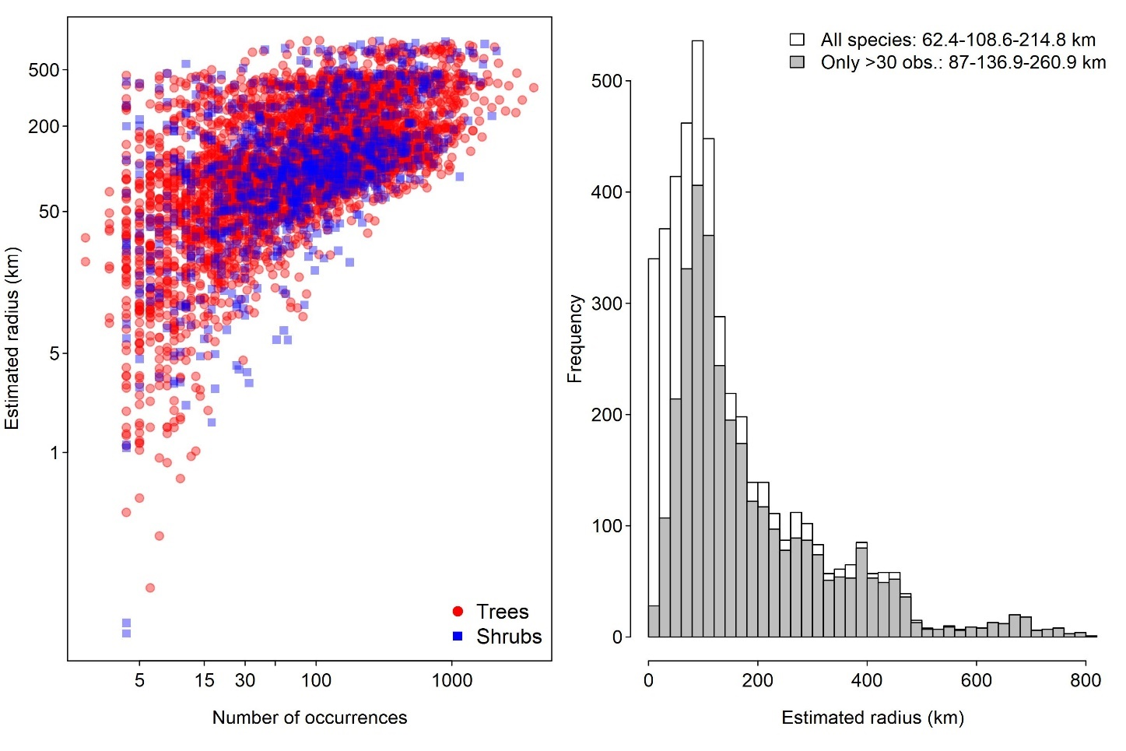

**Figure SV**. The relationship between the estimated radius of dispersal between subpopulations (in km) and the number of occurrences available (left panel) and the distribution of the estimated radius (right panel). In the left panel, tree species are presented by red circles, while shrubs are represented by blue triangles. In the right panel, the histograms were produced using the estimates for all species (white bars) and only for species with more than 30 occurrences available (grey bars) and we also present at the top-left the median and the first and third quantiles for both distributions.

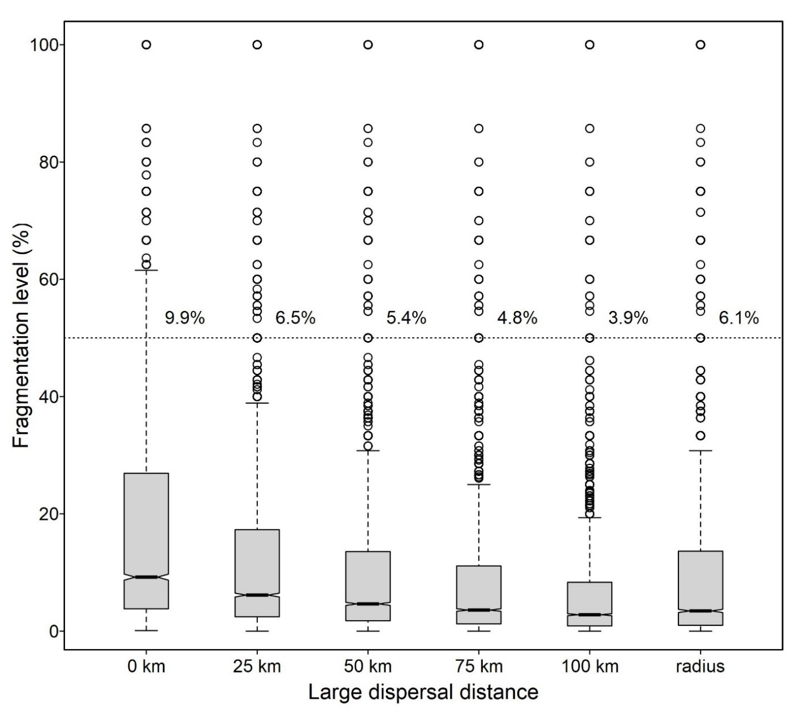

**Figure TT**. The impact on species fragmentation level of using fixed values from 0 to 100 km or the species-specific radius estimated based on the maximum distance between species occurrences as proxies to large dispersal distances. These distances are used to detect subpopulations and thus to calculate the fragmentation level of species, which is taken to be severe once it is greater than 50% (dashed horizontal line). For each of the distances considered, we present the box-and-whisker diagrams that summarizes the distribution of species fragmentation level and the proportion of the species presenting indications of severe fragmentation.

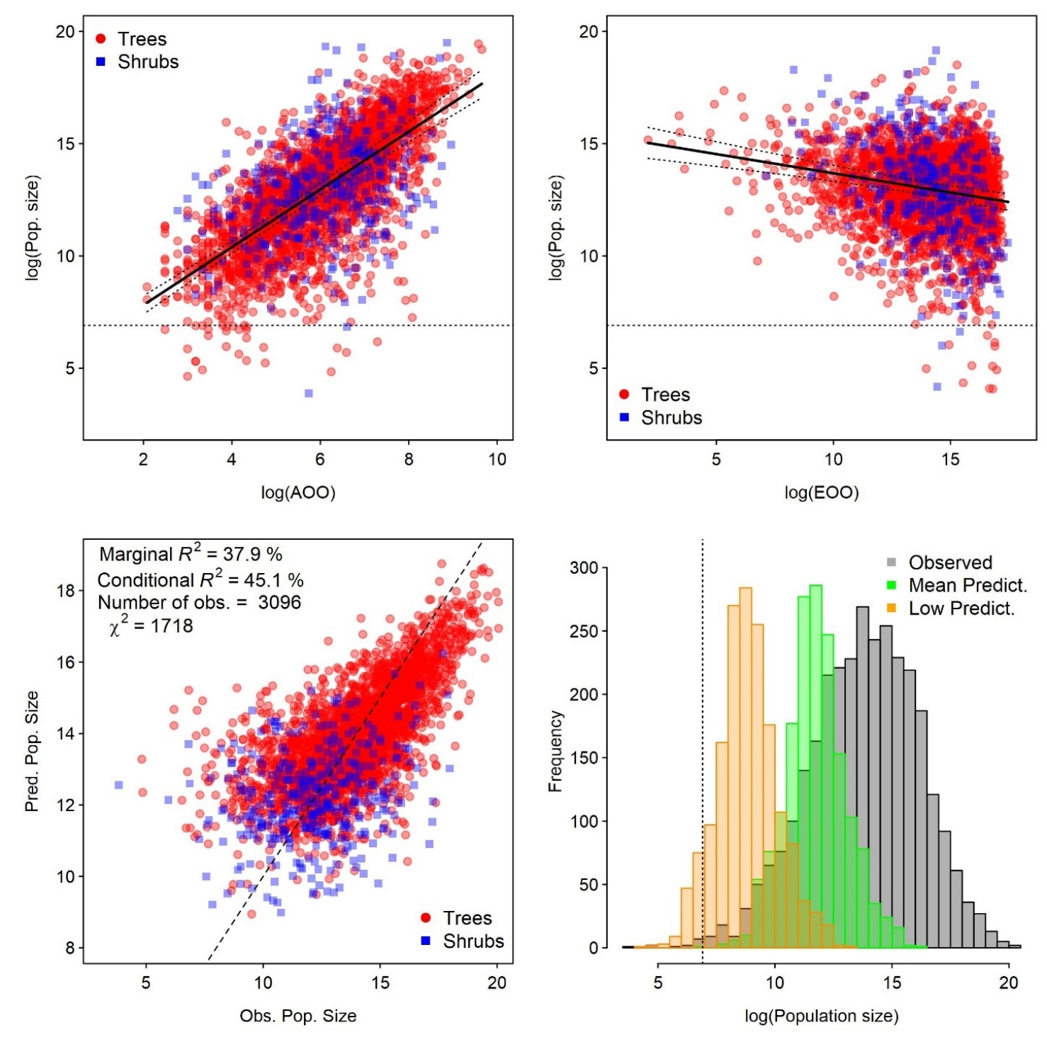

**Figure ZZ**. Results of the linear mixed-effect model used to estimate the population size of species (PS) from their range metrics (i.e. AOO and EOO) and other co-variables (i.e. taxonomy, growth form, and degree of endemicity). In the top panels, we present the relationship between population size with AOO and EOO, and in the bottom-left panel the comparison of the model predictions and the observed values, for tree species (red circles) and shrubs (blue squares). In the bottom-right panel, the vertical dotted line marks the critical population size (i.e. 1000 mature individuals) to the application of the IUCN criterion D.

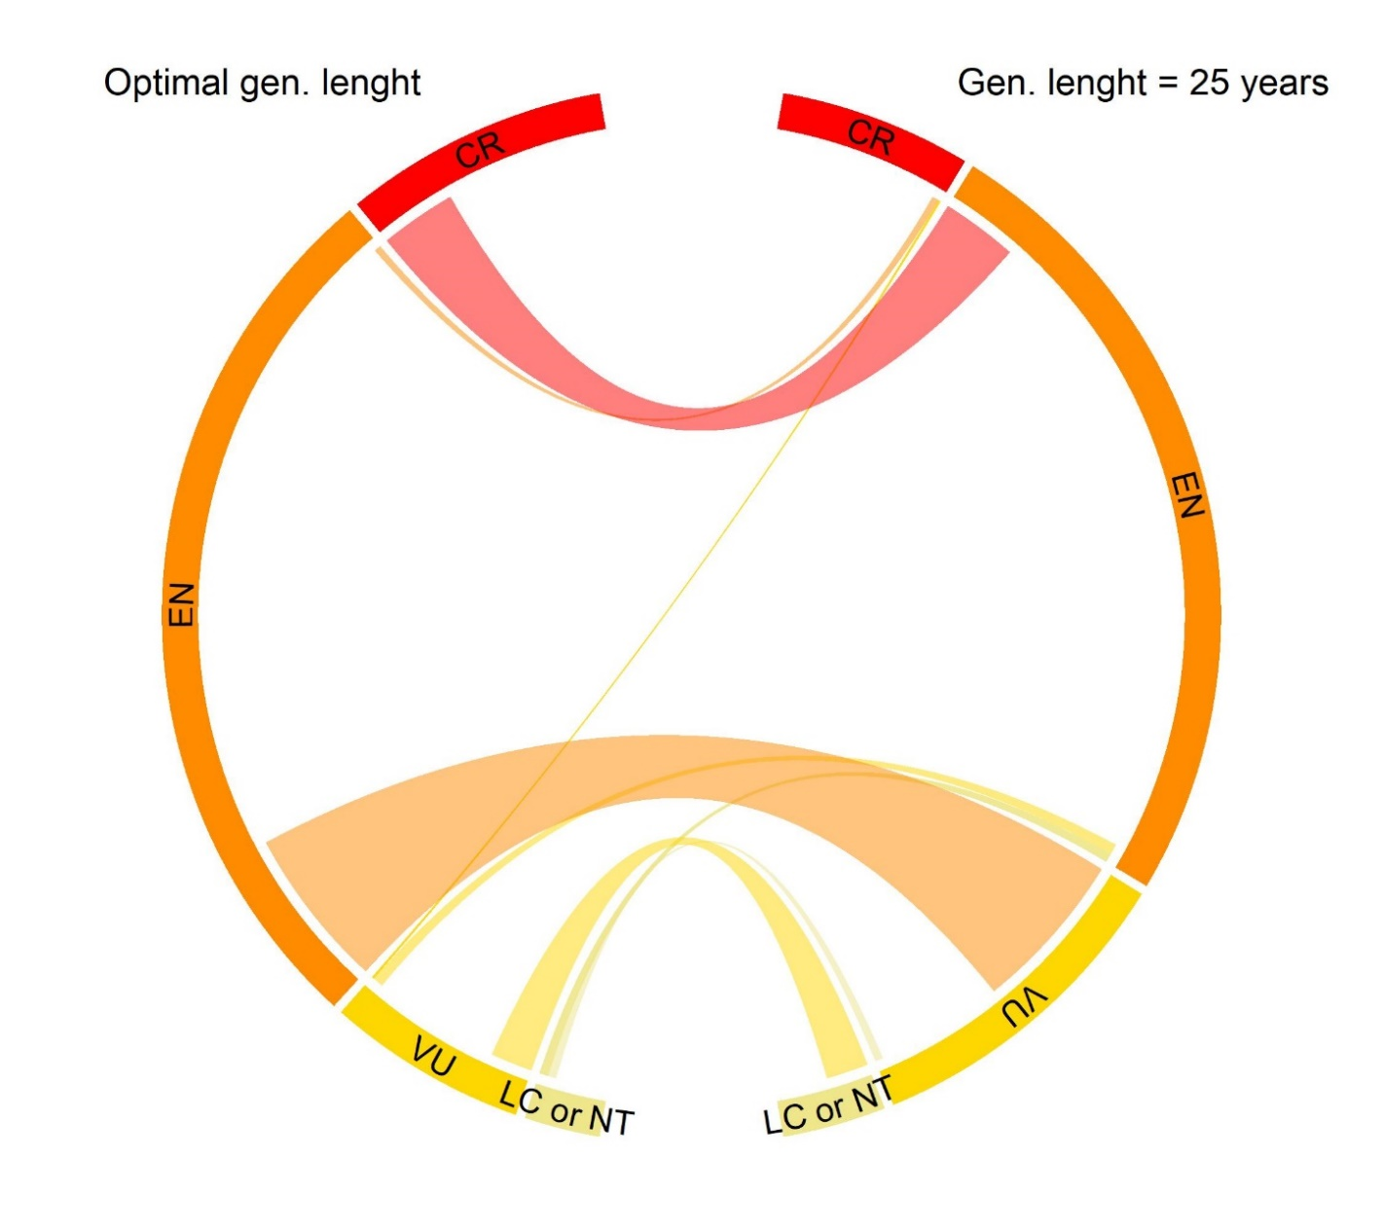

**Figure SWb**. Comparing the overall results of the species conservation assessments using group-specific generation lengths (left arc) to those obtained using a low and fixed value of 25 years of generation length for all species (right arc). Legend: LC or NT = Least Concern or Near Threatened (light-yellow); VU = Vulnerable (yellow); EN = Endangered (orange); and CR= Critically Endangered (red).

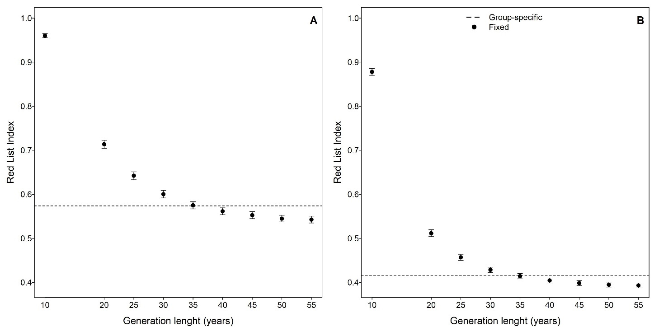

**Figure SX**. Comparing the Red List Index resulting from the application of IUCN criterion A using of the group-specific values (dashed horizontal line) and fixed values of generation lengths for all species (black dots) for sub-criterion A1 (panel A) and A2 (panel B). We used fixed generation lengths between 10 and 55 years and for each one of them we provide the 95% confidence interval estimates of the index obtained using 5000 bootstrap simulations. Since we set 1850 as the time when the study area had 100% of available habitat, the use of generation lengths >55 years did not change the resulting value of the index.

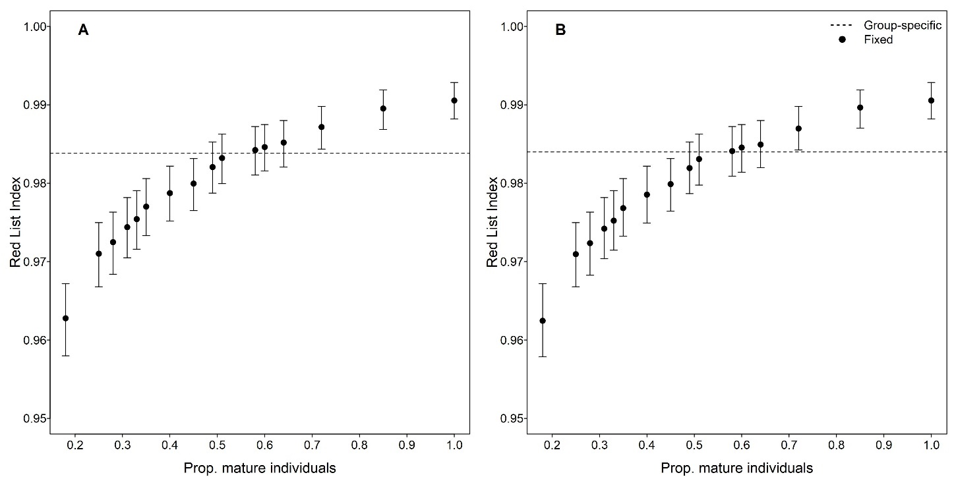

**Figure SY.** Comparing the Red List Index resulting from the application of IUCN criterion C using of the group-specific values (dashed horizontal line) and fixed values of the proportion of mature individuals in the total population (black dots) for the group-specific (panel A) and 25 year generations lengths (panel B). We used proportions between 0.2 and 1, which corresponded to the values used in this study (**Table SU**) and for each one of them we provide the 95% confidence interval estimates of the index obtained using 5000 bootstrap simulations.

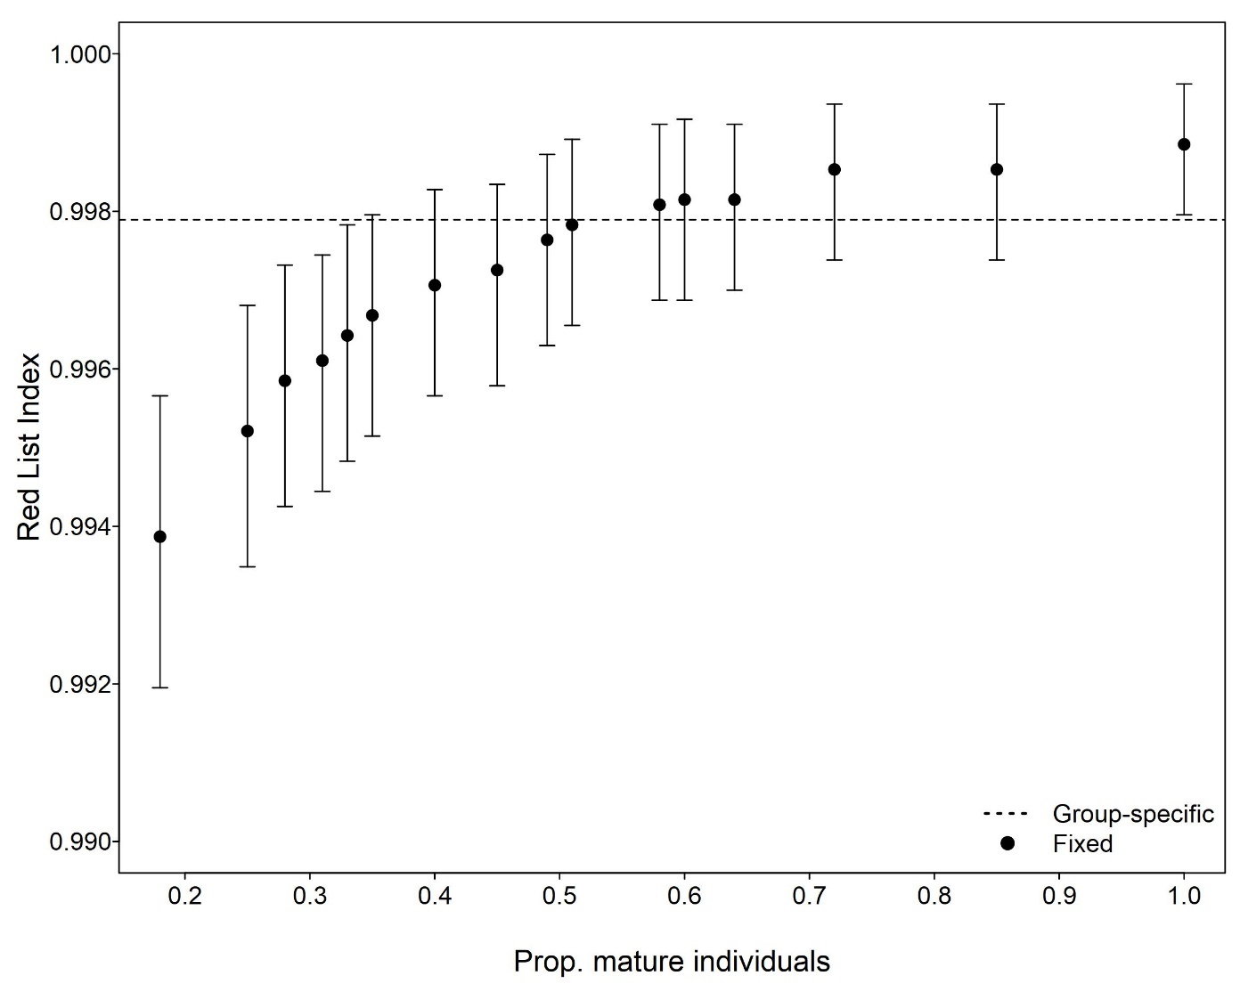

**Figure SZ.** Comparing the Red List Index resulting from the application of IUCN criterion D using of the group-specific values (dashed horizontal line) and fixed values of the proportion of mature individuals in the total population (black dots). We used proportions between 0.2 and 1, which corresponded to the values used in this study (**Table SU**) and for each one of them we provide the 95% confidence interval estimates of the index obtained using 5,000 bootstrap simulations.

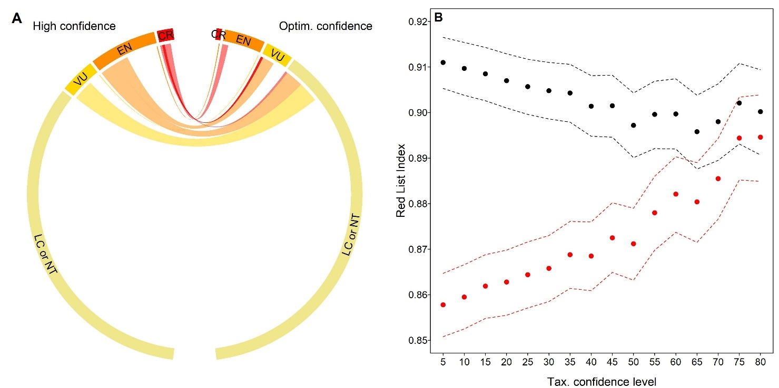

**Figure SU.** The effect of including not only the records validated by taxonomists in the assignment of the threat categories for each species (A) and in the overall Red List Index (RLI) for the assessment of all Atlantic Forest species (B). In panel A, the species conservation assessments using only records validated by taxonomists (high confidence) is compared with an optimum confidence obtained from a scheme to add records not validated by taxonomists for species with less than 75 occurrences with high levels of taxonomic confidence (see Materials and Methods and **Table SX**), which resulted in a median of 72% for the taxonomic confidence level of all the species assessments conducted here, including 34% of them having assessments using only records validated by taxonomists (i.e. taxonomic confidence level= 100%). In panel B, the RLI values (points) and their 95% confidence interval (dashed lines) were obtained for sets of species obtained by including only those above a certain threshold of minimum taxonomic confidence level. Results for the optimum confidence are show in black, while those of high confidence are presented in red. We used as minimum thresholds values between 5% and 95% with intervals of 5%, but only the results until the threshold of 80% are presented (after this point the curves start to converge). Legend: LC or NT = Least Concern or Near Threatened (light-yellow); VU = Vulnerable (yellow); EN = Endangered (orange); and CR= Critically Endangered (red).

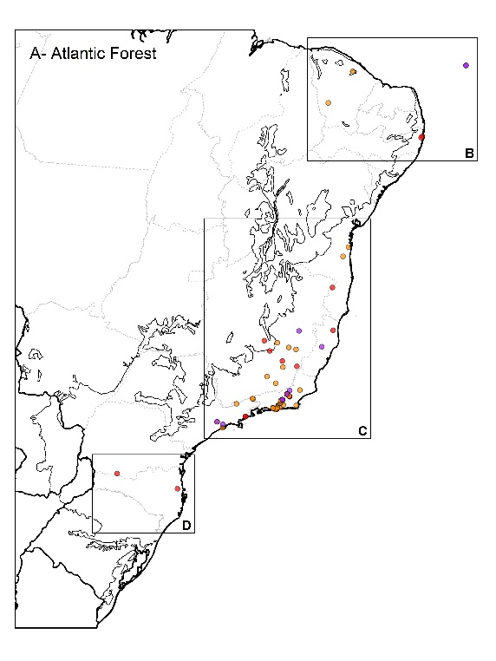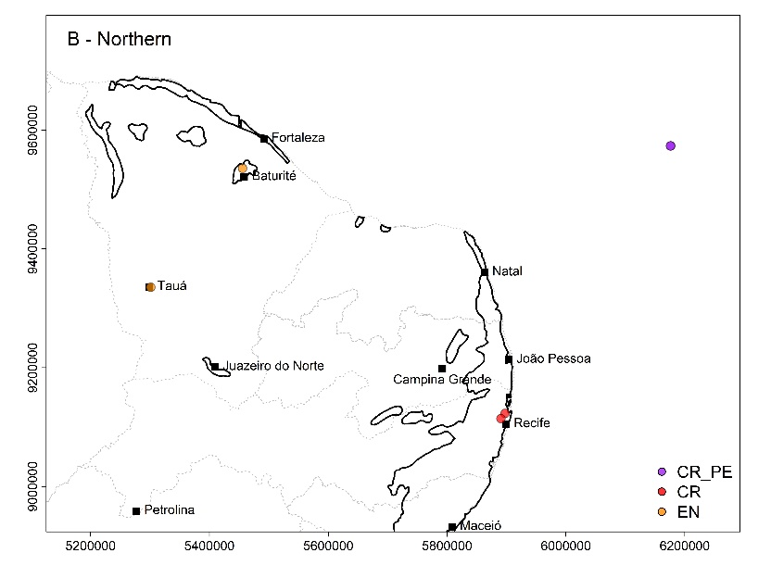

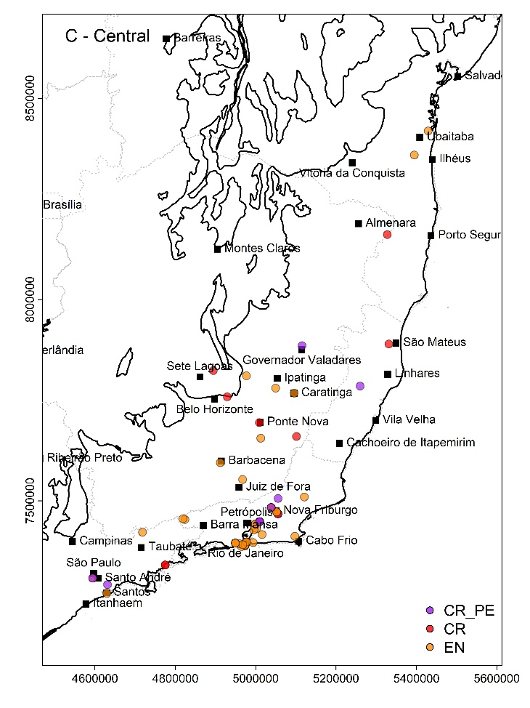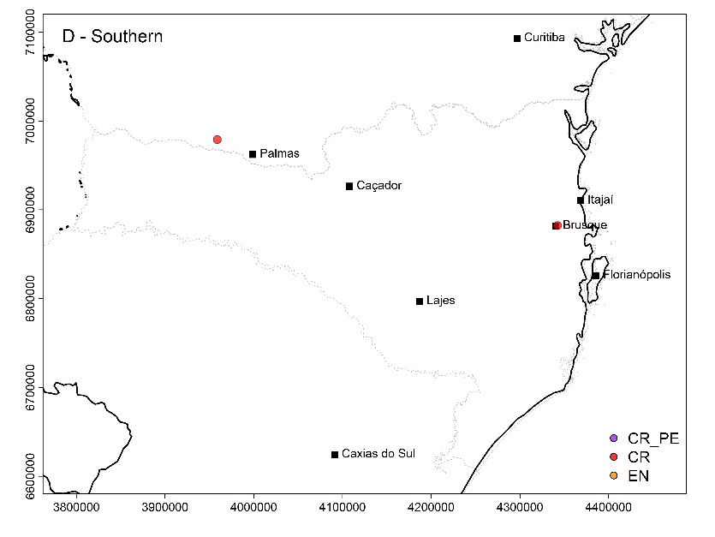

**Figure SP.** Occurrences of the Atlantic Forest endemic tree species without valid record over the past 50 years (A), with the details for the northern (B), central (C) and southern parts of these occurrences (D) and the threat category assigned here for each of these species. Critically endangered species known only from their type specimens, are tagged as possibly extinct (see text for details). Major cities and those close to the occurrences are marked with a black triangle. Maps projected using SIRGAS 2000 (EPSG:5641; Ellipsoid: GRS 1980). Units are in meters.

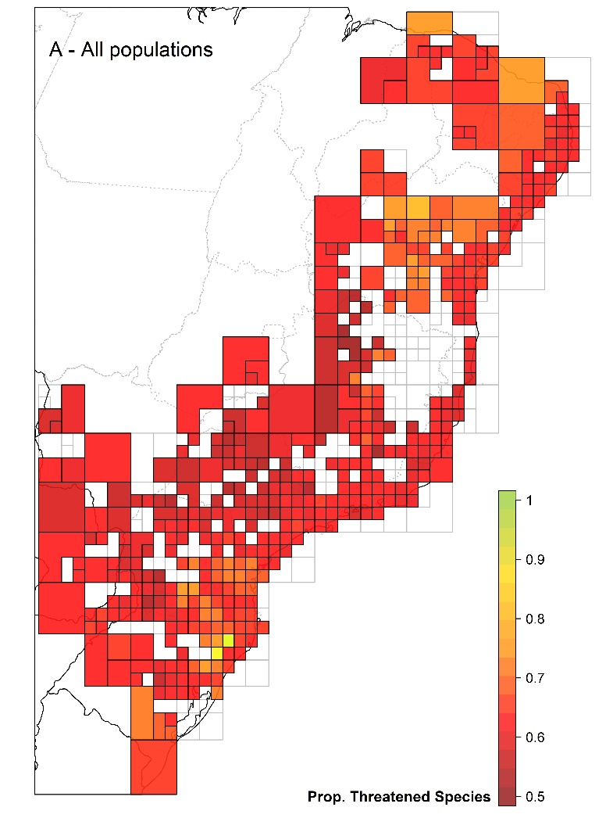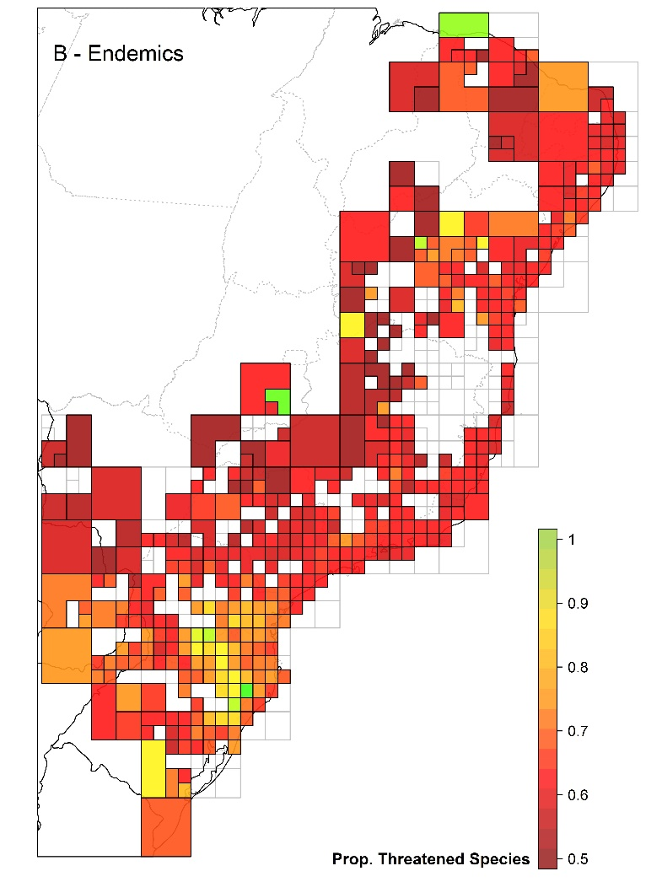

**Figure SR.** Distribution of the observed proportion of threatened considering (A) all tree species populations and (B) only the endemic tree species across the Atlantic Forest biodiversity hotspot.

Cell sizes in the spatial grid varied from 0.5° to 2°, according to the number of species occurrence records available in different parts of the Atlantic Forest. The proportion of threatened species was obtained simply as the number of threatened species (i.e. IUCN categories VU, EN and CR) divided by the total number of species per grid cells (see Methods for more details) and it ranges from 0 (no threatened species - green) to one (all species are threatened). In the color scale, dark-red correspond to highest (worse) proportion of threat, while colours towards green correspond to the lower (better) proportions of threat. Grid cells that did not present a minimum sampling coverage for analyses (see text for details) are not color-filled and are delimited in grey. In both panels, dark lines are the limit of South-American countries and dark-grey lines are the division of the Brazilian states. Maps projected using SIRGAS 2000 (EPSG:5641; Ellipsoid: GRS 1980).

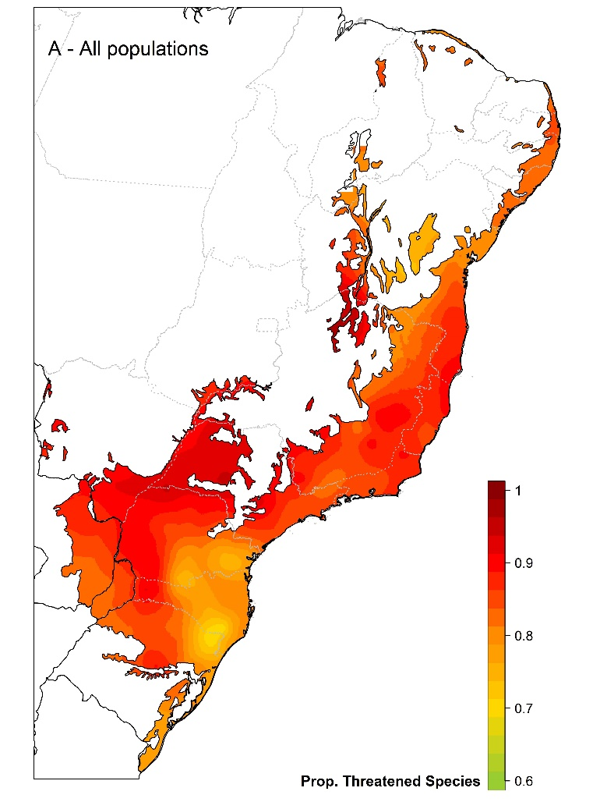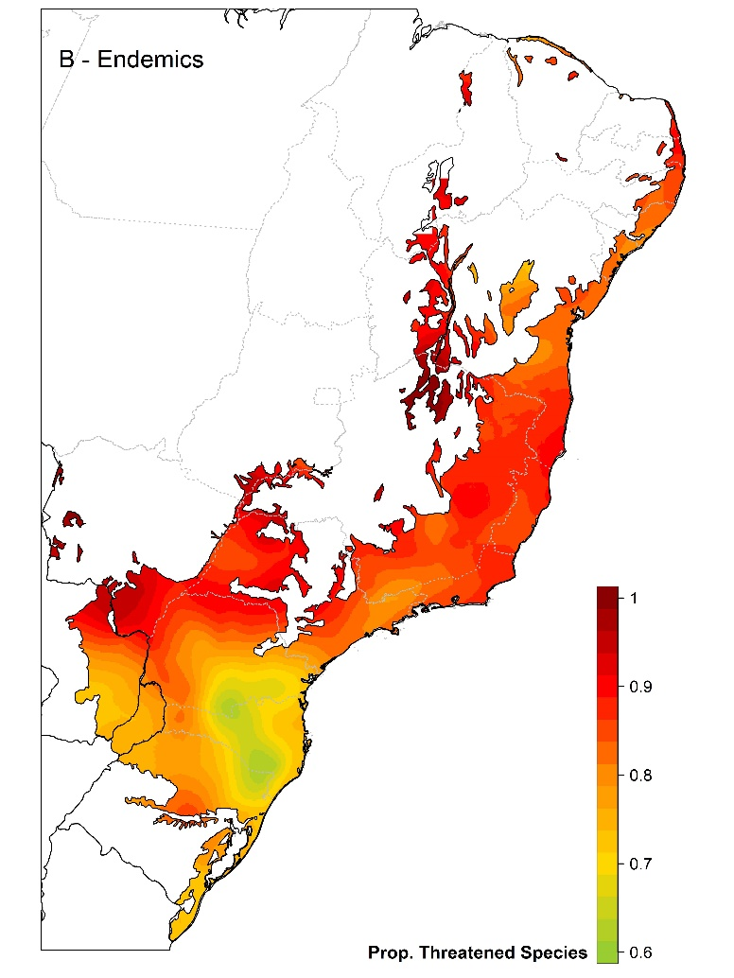

**Figure SQ.** Spatial interpolation of the proportion of threat considering (A) all tree species populations and (B) only the endemic tree species across the Atlantic Forest biodiversity hotspot. The proportion of threatened species was obtained simply as the number of threatened species (i.e. IUCN categories VU, EN and CR) divided by the total number of species per grid cells (see Methods for more details) and it ranges from 0 (no threatened species) to one (all species are threatened). In the color scale, dark-red correspond to highest (worse) proportion of threat, while colours towards green correspond to the lower (better) proportions of threat. In both panels, dark lines are the limit of South-American countries and dark-grey lines are the division of the Brazilian states. Maps projected using SIRGAS 2000 (EPSG:5641; Ellipsoid: GRS 1980).

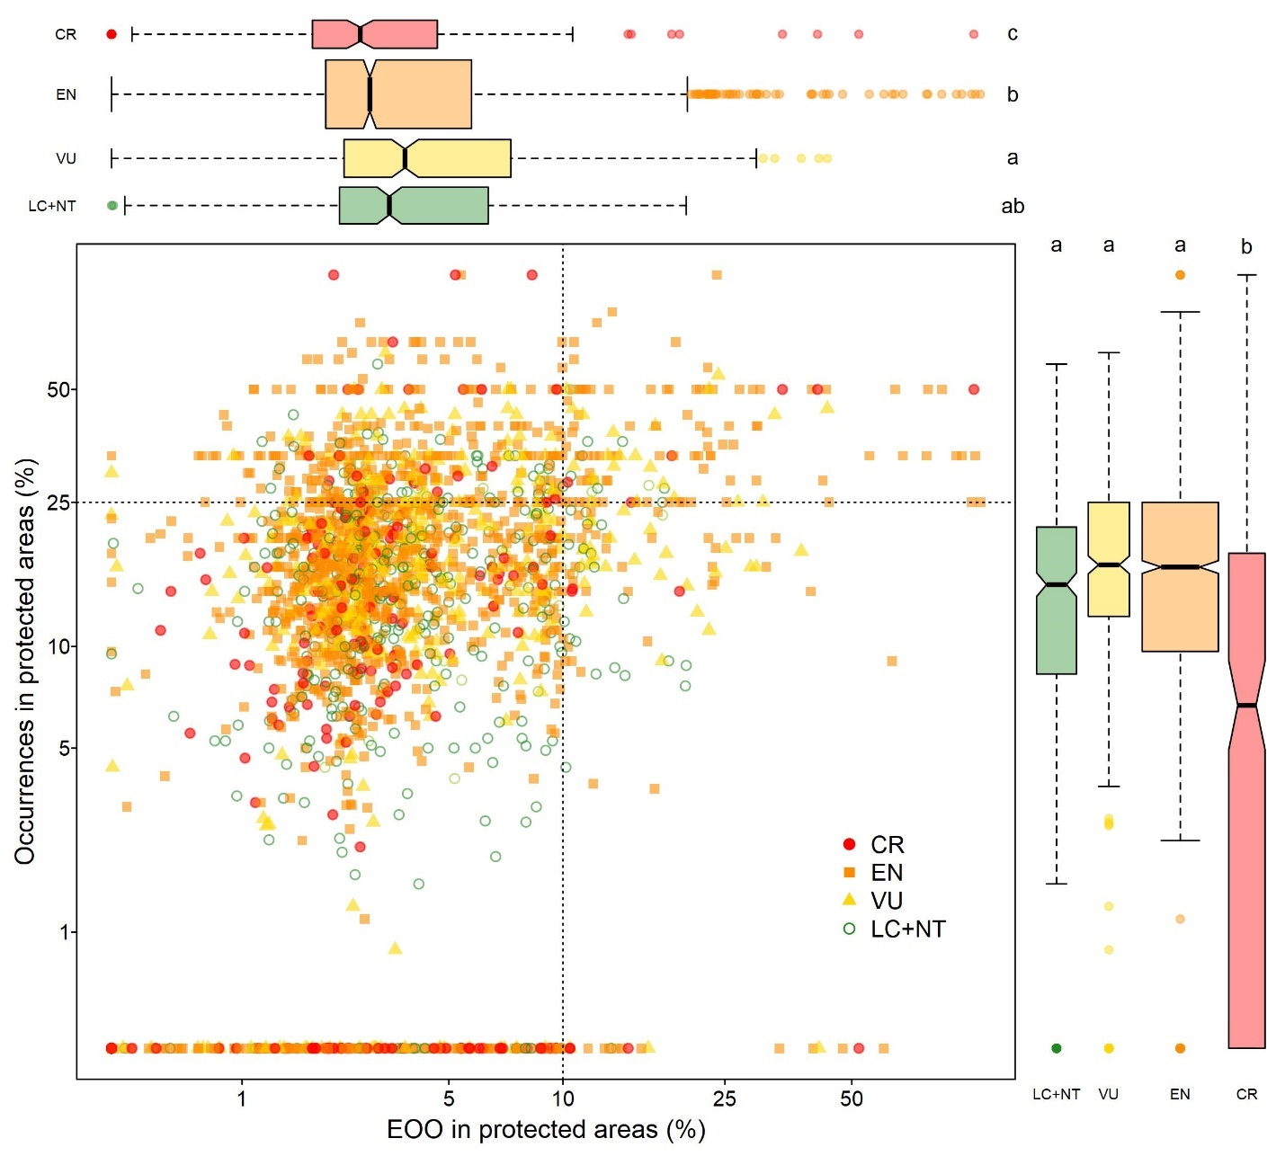

**Figure XX.** The proportion of occurrences within protected areas against the proportion of protected area within the terrestrial extent of occurrence (EOO) for each species, separated by different IUCN categories of threat. Only the Atlantic Forest endemic trees (colored symbols) that we could obtain the species EOO are presented (*n*= 2464) and colors are used to differentiate the categories. By the margin of each axis, the box-and-whisker diagrams summarize the distribution of both variables by categories of threat. There were significant differences for the number of occurrences (*F*-statistic= 62.9, *p*-value < 2.2×10-16, degrees of freedom= 2457) and proportion of EOO in protected areas (*F*-statistic= 9.0, *p*-value= 6.3×10-6, degrees of freedom= 2307). For both variables, the results of the Tukey’s honest significance test for difference among the means are presented at one of the extremes of each box-and-whisker diagram. Note that *x*-axis is in log-scale. Legend: LC+NT= Least Concern and Near Threatened (green); VU = Vulnerable (yellow); EN = Endangered (orange); and CR= Critically Endangered (red).

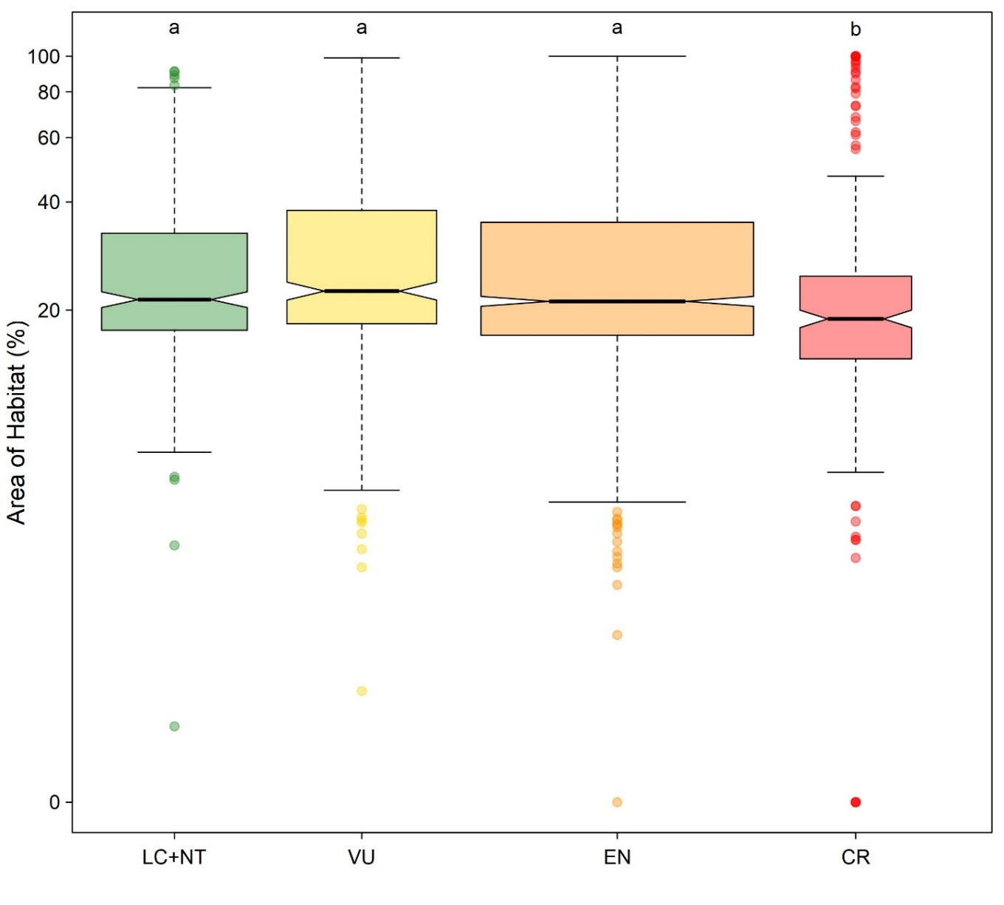

**Figure WW.** The proportion of the terrestrial area of habitat (AOH) for the Atlantic Forest endemic tree species separated by different categories of threat. The comparison of AOH across categories of threat revealed significant differences among them (*F*-statistic= 11.7, *p*-value= 1.3×10-7, degrees of freedom= 2305) and the results of the Tukey’s honest significance test for these differences are presented at the top of the box-and-whisker diagram. Note that *y*-axis is in log-scale. Legend: LC+NT= Least Concern and Near Threatened (green); VU = Vulnerable (yellow); EN = Endangered (orange); and CR= Critically Endangered (red).

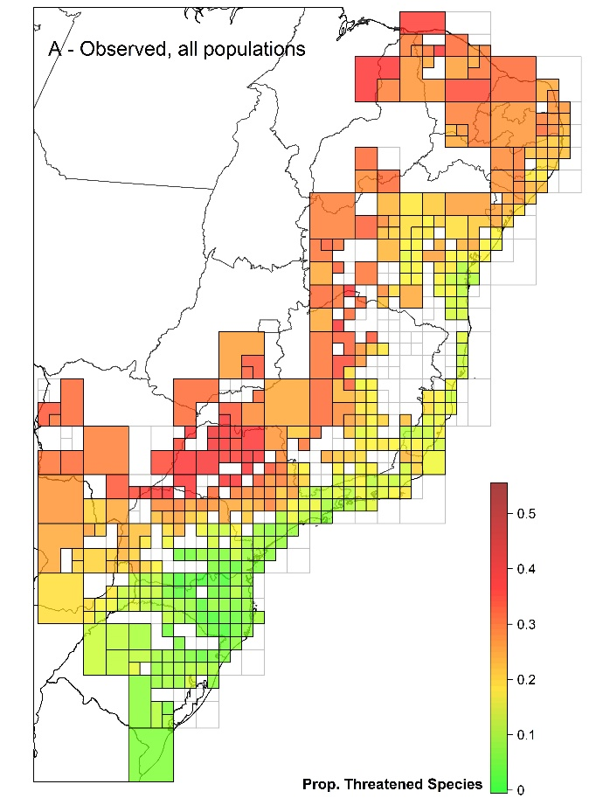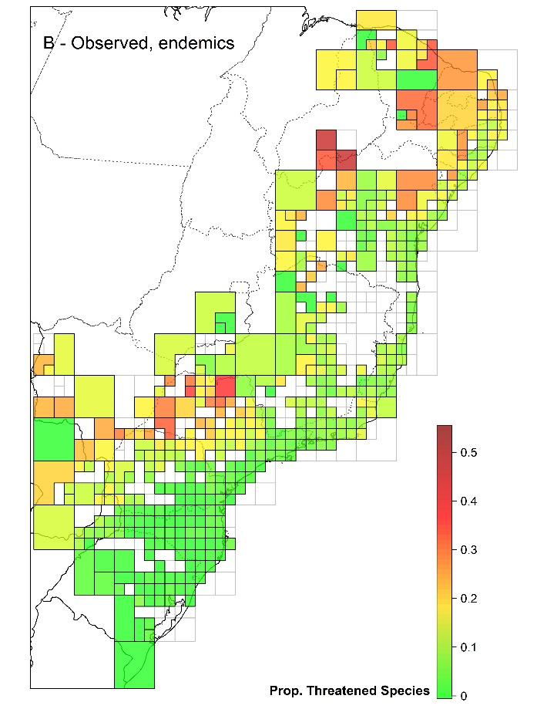

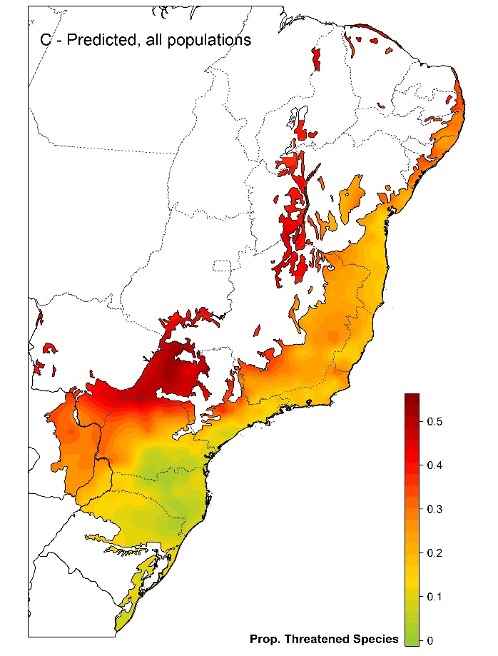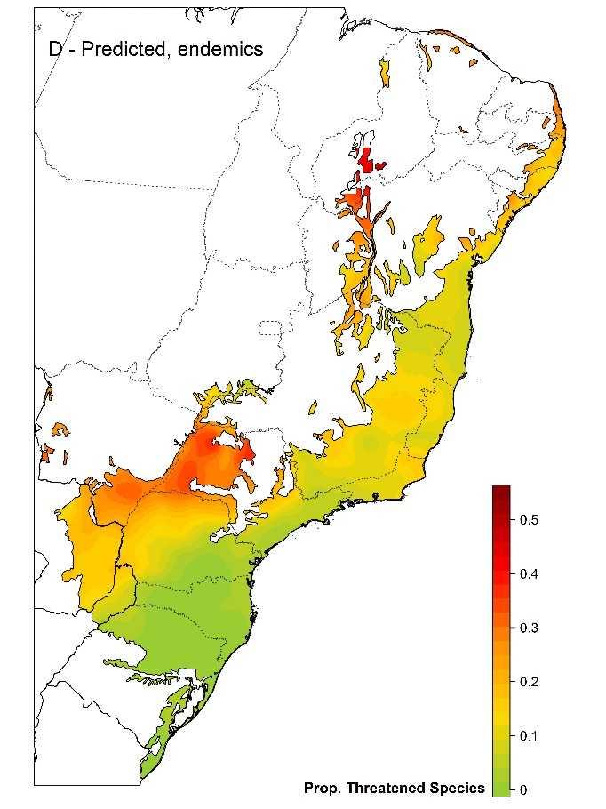

**Figure SR.** Observed and predicted (i.e. spatial interpolation) of the proportion of Critically Endangered (CR) species across the Atlantic Forest considering (A, C) all tree species populations and (B, D) only endemic species. In all panels, green correspond to the lowest proportion of CR species, while colours towards dark-red correspond to the higher proportions of threat. Details on the spatial grids (panels A and B) and how the proportion of CR species were obtained are the same of Figures SR and SQ. Maps projected using SIRGAS 2000 (EPSG:5641; Ellipsoid: GRS 1980).

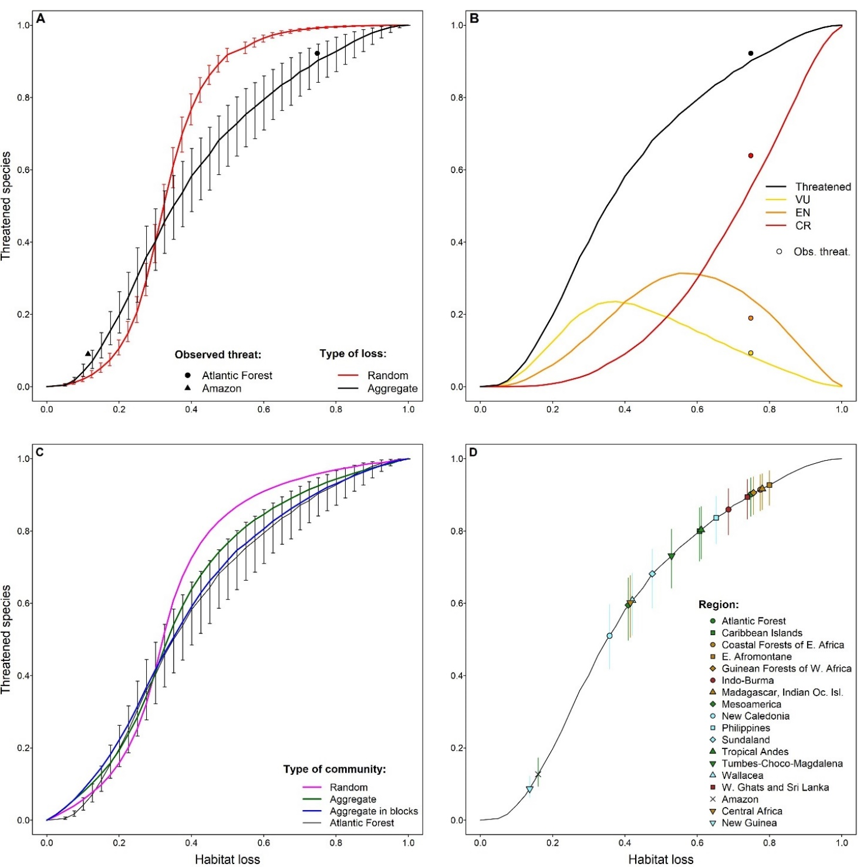

**Figure ST.** The relationship between the proportion of habitat loss and the proportion of threatened species based on population size reduction (i.e. IUCN criterion A). This relationship was derived for the spatial distribution of the endemic Atlantic Forest trees using 500 simulations of random and aggregated patterns of habitat loss (i.e. deforestation) to infer the (A) overall number of threatened species and (B) the proportion of species in each threat category, which are compared to the observed assessments presented here for the Atlantic Forest (colored points) and elsewhere for the Amazon (black triangle). This relationship was also explored for (C) simulated communities with different patterns of species aggregation under aggregated habitat loss. The relationship between threat and aggregated habitat loss for the Atlantic Forest was then used to (D) predict the number of threatened species for 18 tropical forests. In all panels, the black bold or thin line is the curve obtained for the relationship between threat and aggregated habitat loss for the Atlantic Forest. For panels A and C, the vertical lines are the first and third quantiles of the 500 simulations distributions, which are used here as lower and upper bounds of the predictions of threat based on habitat loss.